CSY2027

**[GROUP PROJECT]**

NAMI

2018-2019

**ASSIGNMENT COVER SHEET**

|  |  |  |  |  |  |  |
| --- | --- | --- | --- | --- | --- | --- |
| **Course:** BSc Computing (SE) | | | | **Year:** 2 | CSY2027 | |
| Group Project | | **Title:** The Design and Development of a Course Management Software System | | | | |
| Date due out: | Date due in: | | Extension date: | | | Extension agreed by: |
| **Student Names (List each member of the group)**  Shivani Purwar -18413701  Ramesh Kumar-18413696  Suman Chaulagain-18406485  Ritesh Jha-  Anup Thapa-18417136  Subesh Thapa-18413712  Chirayu Subedi-18418325  Sidhhant Ghimire-18406491  Madhu Sudan Rana- | | | | | **Tutor:** | |

**ASSESSMENT FEEDBACK:**

|  |  |  |  |  |  |  |  |  |
| --- | --- | --- | --- | --- | --- | --- | --- | --- |
| **RATING SCALE** | **Excellent** | | **Good** | | **Satisfactory** | **Needs some more work** | | **Needs much more work** |
| Elicitation Plan/ Interview(s)/Findings (10%) |  | |  | |  |  | |  |
| Requirement Specifications Documentation  (10%) |  | |  | |  |  | |  |
| System Design Documentation  (25%) |  | |  | |  |  | |  |
| Prototype Functionality and Quality of Application Code (35%) |  | |  | |  |  | |  |
| Test/Evaluation Strategy  (10%) |  | |  | |  |  | |  |
| Group Cohesion, Teamwork and Project Management/ System Presentation (10%) |  | |  | |  |  | |  |
| Specific aspects of your assignment that the marker likes: | | | | Specific aspects of your assignment that need more work: | | | | |
| Tutor’s Signature: | | Date: | | | | | Grade: | |
|  | |  | | | | |  | |

Table of Contents

Introduction: 4

Project Background 5

Project Aims and Objectives 5

Aims: 5

Objectives**:** 6

Project Development Methodology 6

Water fall methodology 6

Problem Domain 6

Designing and analyzing phase 7

Requirements Engineering 7

Elicitation Activities 7

Interview plans and findings 7

Other problem domain research 13

Comparable Software System Review 13

Requirement Specification 15

Problem Domain Description 15

Functional Requirements 23

Performance requirements: 34

Design Constraints 34

Commercial Constraints 35

Acceptance test: 36

System Analysis & design 37

Preliminary Design Stages 37

Textual Analysis 37

Significant Events analysis 38

Detailed Static System Designs: 42

First Draft BON System Architecture Diagram 42

BON Cluster Charts 43

BON Class Charts: 45

Detailed Dynamic System Designs 47

Event Charts 47

Object creation Charts 47

System Scenario Charts 47

Dynamics Diagram 47

System Database Design 48

E-R Model 49

System Interface Designs 54

Draft Interface Designs 54

Wireframes 54

System Navigation Diagram 70

System Screen Mock-ups 71

Design Revision 75

Heuristic Evaluation 75

System Build and Technical Notes 77

Technically Difficult Code Selections 77

On-going Testing Methodology 77

Final System Interface Displays 77

Test Strategy 80

Overview of Test Strategy 80

Sample Test Results 80

Black Box Testing 84

System Evaluation 85

Usability Evaluation Strategy 86

System Pilot Trials 86

System Trial Results: 87

Project Conclusions 87

Project Management 89

Project Gantt Chart/WBDS/Activity List 89

Project Meeting Minutes 89

Project Quality Plan/ Strategy 90

Project Work Log 91

References 91

Appendix 92

Presentation Slides 92

# **Introduction:**

This report is shaped by the Wood land university which is providing wide range of degree courses. As woodland university wishes to reorganize their system in computerized way, so they approach our software company to make computerized course management system. Where the system should be user-friendly and should be flexible to manage data of the staffs and students with all their grades, attendance, course, module year wise.

This system is built with the help of PHP server site scripting language whereas H refers to hypertext and Pre-Processor, AS PHP can run easily in most of operating system and can written loosely which helps to save time and efficient. The most remarkable feature of PHP is that it ropes with wide range of database. It is so easy to use any specific data layer or abstraction layer like MySQL, PDO etc.

The system is design in such a way to make it user friendly as possible as it can be. Home page and all other pages are designed by using HTML and CSS added so to make it eye Catchy. As the system created will be basis in pilot system explicitly for computing department. Pilot system refers to single use multitasking operating system.

## Project Background

Wood land university is a higher education institute which provides wide ranges of degree specifically for computing department. Where DR. SIMON is course leader who requested us for the software which can hold the data of staff and students with all the course, module, grade, attendance with the relevant data in short, the software will be constructed in course management system. Also, the software must be based on pilot system mean single-user with multi-tasking operating system.

As the current system of WLU is totally depend in paper based, which is not effective and relevant. Also, in fast growing world time and security becomes a basic requirement, so to save the time and make the current system more relevant and secure the university decide to have its own new software.

## Project Aims and Objectives

### Aims:

* To produce relevant output
* To make the system secure.
* To computerize the current clerical system.
* To save precious time
* To maintain all the records of staff and students
* To enroll new students with courses and module they belong
* To upload all the courses related to specific module.
* To upload assignment by staff and student can submit.
* To upload video in specific module.
* To make specific job in process
* To amend, archive, create, display, assign students, staffs, module etc.
* To show grades of every students and manage assignment management
* To store record of attendance week wise.
* To create, amend, assign, display the personal tutor management.
* To create, amend, delete, archive, display timetable management.
* To prompt, display, amend, and initiate automated action for dairy management.
* To print and generate the report or management.

### Objectives**:**

* Planning for elicitation activities.
* Planning for interviews
* Prepared question for interview with module leader, course leader, Admin, senior lecture, existing student.
* Find out the problem with existing system and of the students as well as of staffs.
* Prepare the beneficial solutions for the system.
* Formulate the entities and related attribute.
* Create wireframes, navigation diagrams, mock ups and activity diagrams.
* Comparing with other software
* Generate reports and BON diagrams
* Draw E-R diagrams and list the related attribute
* Code section
* Present good presentation.

## Project Development Methodology

Project development methodology refers to the technique, logic rules which a programmer will be using throughout the project. As it essential part of any project because the efficiency of work depends how the programmer choose the work and how they put their logic in it.

### Water fall methodology

This waterfall methodology is must traditional methodology which splits the task in most noteworthy way. The output from this method is not delivered until the process is not completed. There are many merits and demerits of this method. As this method is cheap and direct way to aims with very short path way. But at same time it’s not that flexible.

### Problem Domain

After having interview with the staff and students of university, problems are analyzed that the university was totally depend upon the paper based system. With the time the clerical inventory system is not that relevant, secure. So producing or applying the computerized system for the management course will reduce huge headache of loads of data, place and time at the time. The main problem with existing system of university is that the data are not secured and relevant. So the software which is going to be built most gives relevant output and also will be secure as it will password protected and students, staffs will have restricted area according to job and their responsibilities.

### Designing and analyzing phase

After analyzing the current system, having personal and secure own software is the best idea for the Woodland university where the software will be in basis of pilot system. Which will amazingly increase the efficiency of the system to access the relevant data at any time as well as will decreases the issue of space.

Whereas the design of the software is simple and user-friendly.

# **Requirements Engineering**

## Elicitation Activities

### Interview plans and findings

|  |  |  |  |
| --- | --- | --- | --- |
| Interviewer | Question no. | Topic Area | Question & Answers |
| Mr. Adam  Blake | 1. | Target | Good morning sir. It’s pleasure to have you here without wasting the time, I need to move straightforwardly on the principal question. The inquiry goes this way. What is the fundamental focus to make computer framework? |
|  |  | Hello. I am so thankful that you comprehended the impediment of the time. Proceeding onward, the framework is computerized based. The fundamental focus to make computer framework is for easy to access, reliable and user friendly. |
| 2. | Breakdown Process | What are the breakdown of process? |
|  |  | Everything is computerized based as I have mentioned earlier. Student apply to student uses student become provisional if the document or the qualification is correct. Student are given a case file and an ID, and a letter is sent to student information and university have 30% acceptance. During welcome way the student accept their offer status has been transfer from provisional to live and qualification is checked. |
| 3. |  | Can you provide me all the number modules in each year? |
|  |  | First year –> 6 modules  Second –> 6 modules  Third –> 5 modules  Dissertation-> double module weightage. |
| 4. | Student Record | After the student graduation record of the graduated student should be kept? |
|  |  | Yes of course, when student is graduated their records are kept for 10 years because whenever student need any document at the point student record become dormant. |
|  | 5. |  | Can student be dormant? |
|  |  | A student can be dormant for multiple purpose in addition to graduate for example withdraw or termination. Normally student file is kept in status. If the student is active or inactive. |
| 6. | Expectation of the system | What is the major expectation of the system? |
|  |  | At first, we must able to check digital check of student profile. Like attendance access sheet and grade sheet. And we can search information and delivered from email or memo. The system should access over a network. It should have a different role to access permission to their role. There should be easy access and prevent from of loss data (backup). The system should able to recognize add up to user based on the permission when login. Security premises should be measured. |
|  | 7. | Performance and usability | How it be help us to improve regarding of performance and usability? |
|  |  | Efficiency is one of important there is as many as information is provided. Ability to receiver information quickly. Faculty member can look after student information; student can easily review their own attendance. Prevent from losses of data and leakage of data. Manage storage space for domain. |
|  | 8. | Additional features | What are additional features would like to have? |
|  |  | The additional features I would to have is social media. |
|  | 9. | Network security | Are there any network security? |
|  |  |  | The network security is to prevent data leakage. I would like you to recommend me some for protection of data. |
|  | 10. | Programming language | Which programming language platform is suitable for your project? |
|  |  |  | I prefer java and c-sharp programming language. My IT team are professional in java and c-sharp platform which is friendly to our staff. |
|  | 11. | Database | Which database is suitable for you in your project? |
|  |  |  | I would like you to recommend me for this I have not much idea in it. |
|  | 12. | Information of database | What about the information for database? |
|  |  |  | We will not provide data but if you want then we should make some agreement else you are going use dummy data and all the information is restored by our management team or admin. So, I will be suitable if you use dummy data in it. |

|  |  |  |  |
| --- | --- | --- | --- |
| Interviewer | Question no. | Topic Area | Question & Answers |
| Module Tutor  Dr. Raj Sign | 1. | Target | As we go through this management system what are the problem in the paper-based system that we can solve in computerized based system? |
|  |  | Of course, there are some problems that our management team are facing due to paper-based system because previously we have clerical based system which is paper based system that is not visible like some of the information must be visible to the authorized only. As module tutor, we can have more additional features in this new system. |
| 2. | Features | What is the feature you need in computerized system as module tutor? |
|  |  | As a module tutor what I need is information about student, module information which can be upload and visible by module tutor. Course material should be displayed in student profile which is upload or added by module tutor. There is different type of module so all the information about the module is added by module tutor. |
| Different type of module have different lecture different assignment or TCA exam or paper based exam so all the need of the module should be added or remove by tutor itself and all the require. |
| 3. | Multi-media | What type of multi-media option would like to have? |
|  |  | For uploading video and it need to have lecture video which student can easily go through the video for their reliable and easy for study. |
|  | 4. | Assignment | What features should be added in TCA exam or assignments? |
|  |  |  | The module either have TCA exam or assignment so you should give different filed according to need. The TCA exam have password and all the password should be hashed or encrypted. And TCA exam is also can be added or remove by the tutor itself. The authority to select whether for exam or assignment is given to module leader. |
|  | 5. | New posts | Would you like to have any blog post? |
|  |  |  | Of course, It would be nice for all student to give information about the module in a single page which will be easier to view by the student. |
|  | 6. | Reviews | Is student review is important in your system in module? |
|  |  |  | Yes. Student review is also important for student where student review about the module rather than review you can add some discussion forum which student can easily communicate with each other or to any module leader about problem facing in their module. |
|  | 7. | Security | Any security premises would you prefer? |
|  |  |  | All the information should be hidden of the student profile like one student should not go through other student profile. Student should not go through module tutor profile. Student grade should be displayed and only seen by the individual one. All the information is added by the tutor and displayed in student profile about the module. |

|  |  |  |  |
| --- | --- | --- | --- |
| Interviewer | Question no. | Topic Area | Question & Answers |
| Mr. Mark Williams | 1. | Target | 1. What are the main problems students are facing in the current clerical documentation? |
|  |  | The problem in system that student is facing by the paper-based documentation is information are not properly visible and grade are printed in hard paper. Once we enroll in university, we are not having proper channel to follow the documentation everything is done manually stored in a hard paper there would be chance of misuse or loss of data. |
| 2. |  | 2. Do you think going computerized will solve these problems of documentation and management? |
|  |  | Of course, I would be a good and new system is applied here nowadays we can find all the system are based online or computerized because there no loss of data, information is stored and prevent of misuses. All the data is easy to access, reliable and user friendly. |
| 3. | Security | As a student can you suggest any security issue? |
|  |  | Security is major issues in computerized system because everything is done through online based or software, exam is done online, assignment is submitting online so there might be chance of loss data or misuse of data. As student should cannot go through one another profile which can lead us to misuse of data or loss of data so this can create a big issue. The security is higher concerned. While enroll in the university it would be easier, reliable to student to apply online. |
| 4. |  | Would you like to suggest us some additional features that we can consider that can help us to make better computerized system as student? |
|  |  | Computerized system will help student to easy, reliable to get information about module, grades, attendance, different online lectures which will help student to preserve time and utilize the time for study and different testing. |
|  | 5. |  | Do you think it will be easy to adopt new management environment for students? |
|  |  |  | The module either have TCA exam or assignment so you should give different filed according to need. The TCA exam have password and all the password should be hashed or encrypted. And TCA exam is also can be added or remove by the tutor itself. The authority to select whether for exam or assignment is given to module leader. |
|  | 6. |  | Would you like to have any blog post? |
|  |  |  | Of course, It would be nice for all student to give information about the module in a single page which will be easier to view by the student. |

### Other problem domain research

### Comparable Software System Review

The features, functionality, merits, demerits, problems, etc. of different web applications of blackboards are analyzed to develop a better application.

Northampton integrated learning environment

Nile is a blackboard for university of Northampton students in which students can login with their university student id and password to access modules, announcements, feedbacks and grades.

Login**:**

This login page contains two text field for id and password.

Homepage**:**

When user get logged in then user can access homepage which contains module lists which student was enrolled. On the right top bar there is a dropdown which contains grades shortcut, messages group information, calendar post.

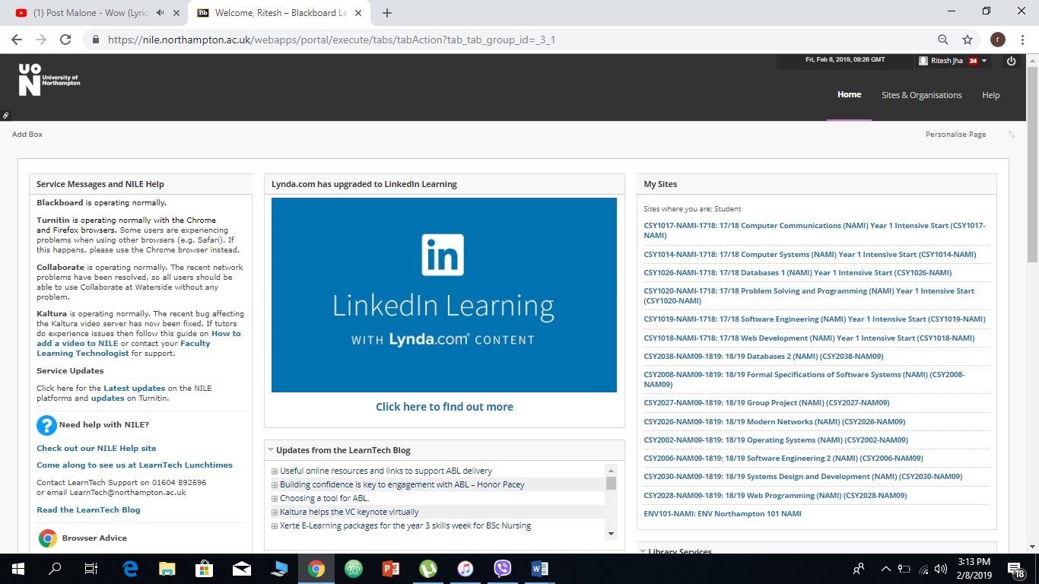

Fig 1: home page

Pros

1. The theme color is eye friendly.
2. Modules are displayed properly.
3. Personalize option is provided to user.

Cons

1. Search option is missing
2. Modules are displayed in which students are not enrolled.

**Module information page:**

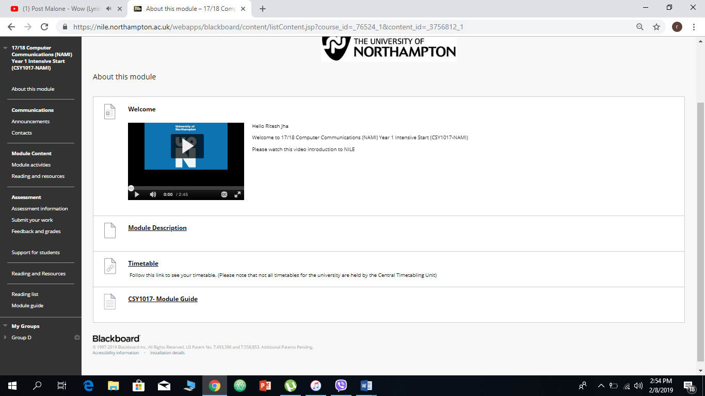

Fig2: module info page

Module information page contains announcement about module update, assessment information, assessment submission in which students can submit their assessment work as zip file, documents, and videos.

Pros:

1. All information about module has been provided to students.
2. Feedback and grades have been separated for every module

Cons:

1. Side bar information has small fonts which makes users difficult to see.
2. Page should have more colors.

**London metropolitan university:**

Evision:

Evision blackboard is provided to London metropolitan university student. Students who are enrolled was provided with unique id and password for accessing to home page.

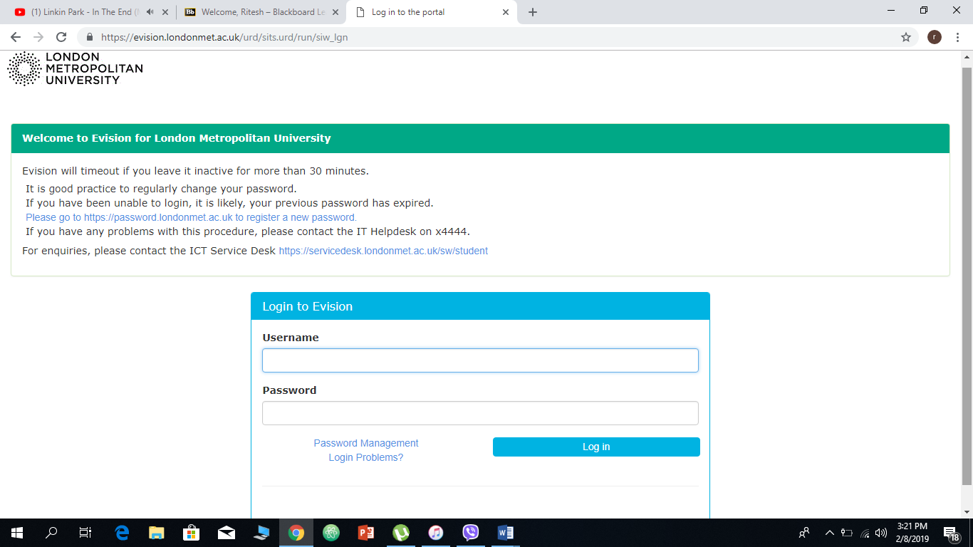

Fig 3: login page

Pros

1. Password management system is provided.
2. User friendly.
3. If incorrect password is entered more than 5 times, the password will be expired.
4. Security protocols are implemented.

Cons

1. The color combination of website is less appealing.
2. Unmanaged space.
3. Lack of contents.
4. Lack of animations.

#### Development Relevant Legislation

1. Intellectual property (IP) rights
2. International cooperation on IP
3. GATT (General Agreement on Tariffs and Trade (GATT)
4. TRIPS (Trade Related Aspects of Intellectual Property Rights)
5. Data protection legislation
6. Data portability right
7. Restrict processing right
8. Object right
9. Rights in relation to automated decision making and profiling
10. Terms and conditions

## Requirement Specification

### Problem Domain Description

#### Existing Business Operation

In this part, the process of existing business operations was discussed with clients and process was logically analyzed by using flowcharts on which old system worked.

1.Admisssion Process

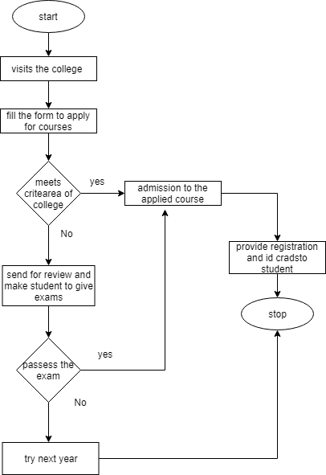

*Fig: old admission process*

2.Announcement Process

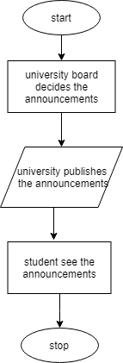

*Fig: University announcements process*

3.Classroom Attendance Process

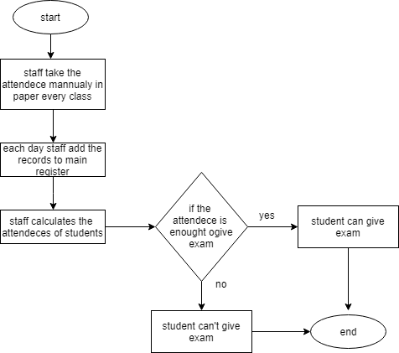

*Fig: old attendance system*

4.Student Remove System

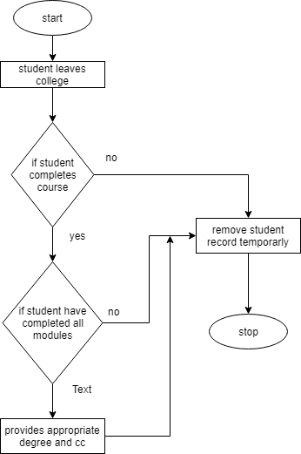

*Fig: remove student from university system*

5.Old Grading System

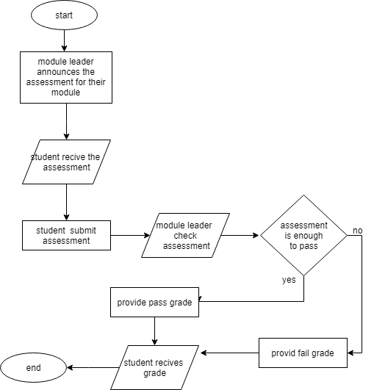

*Fig: old assessment and grade system.*

6. Addition of new staff in system

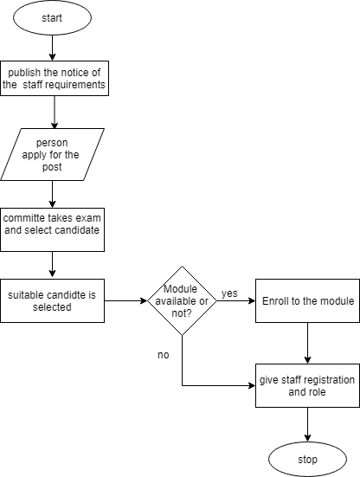

*Fig: addition of new staff in system*

#### Summary of existing business limitations.

**Problem Domain Description**

After proper study, comparison with multiple systems and with thorough interview sessions with all the parties all the problem domains addressed were processed. It was clearly visible that woodland university was struggling with the traditional way of handling records and profiles. Final conclusions regarding problem domain was concluded.

#### Summary of Existing Business Limitation

Woodlands University College an educational institution follows old clerical system on course

management system. Following the old recurring process is a very time consuming and laborious work. Thus, hoping to rectify the issue and further benefiting other faculties including the

computing department we prepared a pilot system for the cause. Presently, it was noted that a lot of inconvenience regarding withdrawal of profile and records of both student and staffs were found. File management was found to be handful as a lot of records were to be taken care of. Some of the existing business limitations that were encountered with the existing clerical system are mentioned below:

1. Security reasons:

Due to poor file management process, the records and the information which are confidential, and which were needed to be handled by only authorized personnel were also possible to be abstracted by unauthorized department which caused information to mislead.

2. Grade Management:

As again due to the poor clerical system, the grade management of students and some staffs were found to be problem. Due to hardcopy prints, due to various natural cause information were not secured which caused undeserving marks to students.

3. Enrollment issue:

The enrolling process which would have been agile if the process was computerized was found to be slow. Documentation of information consumed more human effort and time.

4. Information distribution:

As no computerized system was followed, for even small notices staffs and students were needed to read through the physical noticeboards. Such process is time consumption of valuable period.

5. Advertisement problems:

For running advertisements, even in today’s technologically advanced era traditional and time-consuming method of using pamphlets and posters were found to be used. A lot of human resource was to be allocated for a small purpose. Especially in the present computerization age being limited to posters and traditional ways of advertising university was severely lagging behind comparing to other universities in terms of attracting students.

### Functional Requirements

In software and system development, functional requirements are a declaration of the intended function of a system and its components. It may be calculations, technical details, data manipulation and processing and other specific functionality that what a system is supposed to accomplish. It is said to be later form of a system design because a design is the outcome of overcoming a certain kind of a problem being faced. It may contain;

* + Operation performed by the system.
* Data to be entered in system.
* Work-flow performed by the system.
* Access rights of users.
* How the system meets applicable regulatory requirements?
* Operation performed in each screen.

#### Access Rights

Access rights are the permissions that are granted to a user, or to an application, to read, write and erase in the computer. The permissions can be applied to individual user. They are defined for computer applications which holds read, write, modify, delete or otherwise access a computer file: ­­­­

|  |  |  |  |  |
| --- | --- | --- | --- | --- |
| **Operations** | **Site Administrator** | **Staffs** | **Students** | **Ex-Student** |
| **Student Records** | Create, Amend, Archive, Display, Assign | Create, Amend, Archive, Display, Assign | No Access | No Access |
| **Staff Records** | Create, Amend, Archive, Display, Assign | Amend, Archive, Display, Assign | No Access | No Access |
| **Course Records** | Create structure,  Amend, Archive, Display, Assign | Create structure,  Amend, Archive, Display, Assign | See the courses and materials. | Can see the courses for 3 years after the graduation. |
| **Module Management** | Create structure,  Amend, Archive, Display, Assign | Add,  Amend, Archive,  Edit,  Display Assign | Can see the modules,  access the study materials, see TCA, archive the module materials, see submitted works. | Can see the modules,  access the study materials, see TCA, archive the module materials, see submitted works after 3 years of graduation. |
| **Assignment Management** | Create structure,  Amend, Archive, Display, Assign,  Delete | Create,  Amend,  Display,  Assign,  Delete,  Mark/Grade | Can attempt assignment,  Download,  Submit,  See grades | Can only see the assignment brief |
| **Attendance Records** | Create,  Amend,  Display,  Delete,  Assign,  Edit | Create,  Amend,  Display,  Delete,  Assign,  Edit | No access | No access |
| **Personal Tutor Management** | Assign,  Display,  Edit,  Amend | Assign,  Add students,  Assign dates, | Take dates,  Request for dates | Take dates,  Request for dates after 3 years of graduation. |
| **Timetable Management** | Create, Delete, Modify,  Assign | Timetable for students, PATs,  Modify | See timetable for lecture and tutorials,  PAT dates | See timetable for lecture and tutorials,  PAT dates |
| **Report Generation/Management** | Create, Display and print report | Create, Display,  Edit and print report | See the generated report | See the generated report |

#### Entity(data) attributes identify:

|  |  |  |
| --- | --- | --- |
| **Name of entity** | **Type/Format** | **Notes** |
| Student id | Integer (8 digits) | Primary key for students |
| Staff id | Integer (8 digits) | Primary key for staffs |
| admin id | Integer (8 digits) | Primary key for admins |
| Password | encrypted String (8 characters) | passwords for admin, students, staffs |
| Email | String (20 characters) | emails of users |
| First name | String (20 characters) |  |
| Surname | String (20 characters) |  |
| Contact address | String (100 characters) |  |

#### Functionally operation logic:

As the system is going online from clerical system. So here are some functionally logical operations in new computerized system in online. The basic flowcharts are as:

1. Sign In

For sign up following steps should be taken;

* User Open the website of University,
* Clicks on Sign in option in homepage,
* When user clicks in sign in option, the form for user id and password opens,
* User enters the correct combination of user id provided by university and password,
* If the password and user id match to database of the server, User home is displayed,
* Else the user is redirected to the same page and allowed to enter new id and password,
* The process is repeated unless the user enters the correct combination of the id and password.

1.Login

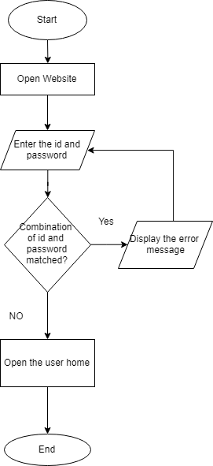

*Fig 4. User login*

2.Log out

If the user wants to logout from the page, following steps took place;

• User clicks logout button,

• Session ends,

• User is redirected to the home login page of system,

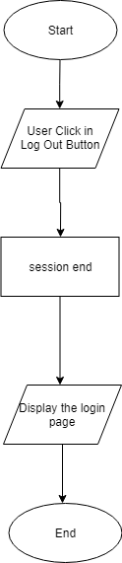

*Fig 5. Flowchart-logout*

2.Adding students:

If the admin wants to add the student in the university the following process took place:

• The admin opens the website and complete the login process successfully.

• The admin enters to student management page where the link is available for adding student using form and through excel file.

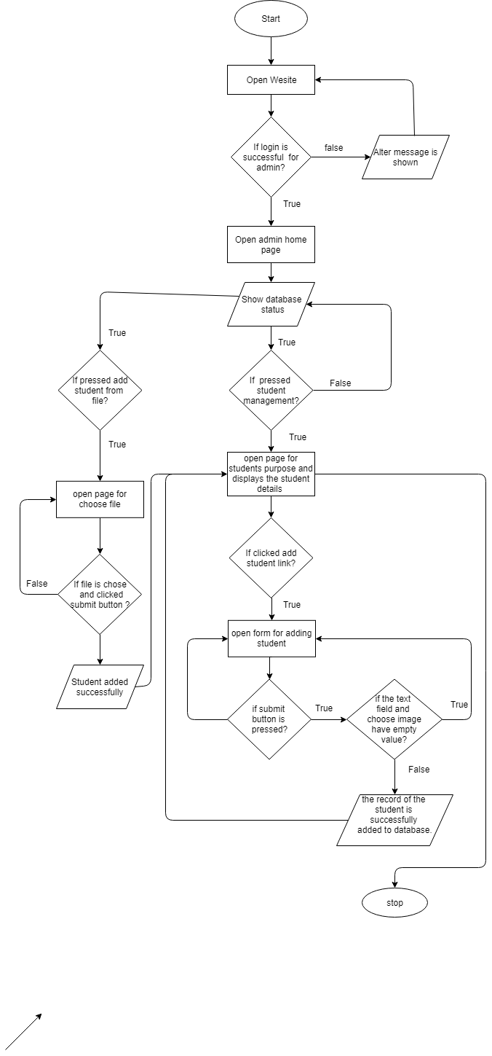

*Fig 6: flowchart showing the addition of student in the university*

3.Add Module:

If the admin wants to add the module in the university the following process took place:

• The system checks whether the admin was logged in or not.

• If the admin was logged in, the page of module management was displayed

• When the submit button was pressed filling the data, the data gets added successfully and the module management page was seen where table was displayed.

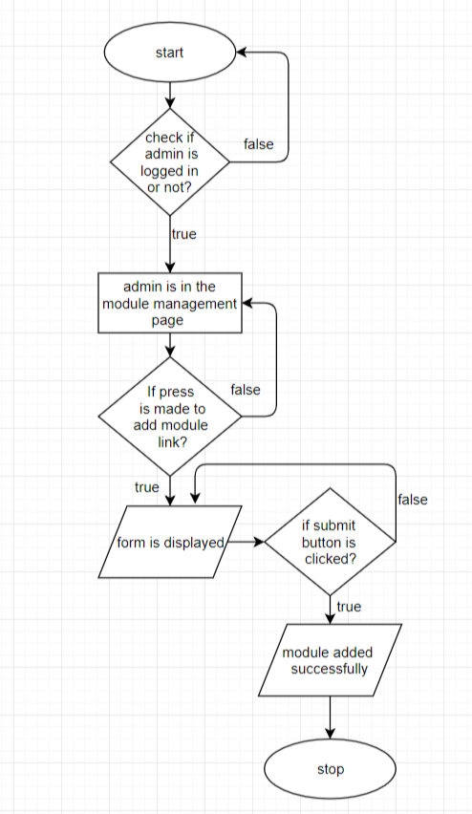

*Fig 7. Process of adding module*

4.Adding Assessment

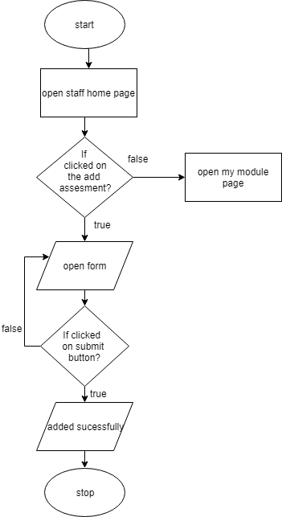

*Fig: Add assessment flow*

#### Provisional product catalogue attributes:

|  |  |
| --- | --- |
| **Attributes** | **Notes/Examples** |
| Admin | Who have all permission granted and can control the software |
| Course | The main courses available in the department. |
| Module | All the modules available under a particular course. |
| Students | All the students enrolled for the course. |
| Ex-Students | Graduated students who can access to the system for three years. |
| Staffs | All the teaching staffs which can access to modules. |
| Attendance | Attendance records for staffs and students. |
| Personal Tutor Management | Lecturer allied to a specific student where students can clear any problems. |
| Timetable | Timetable for the lectures, tutorials and PATs for students and staffs. |
| Report | All the grades and activities of a student. |
| TCA | Written exams for annual or terminal examination for students. |
| Assignment | The project work given to students by University to students for a module. |
| Grades | All the grades received by the students. |
| Diary | stores all the activities performed by the student. |
| Submission date | Last date for the submission of assignment |
| PAT date | Date given by the tutor to the student for PAT |
| Late Submission | Late submission date for the assignment |

#### System Input/output formats

**1. Assignment notice**

Dear student,

The assignment for the (Module Name) ... is available in the assignment information section of this module in our system. The submission date for the assignment is (Submission date).

Module Name: ……………...

Title of assignment: ………….

Title of course: ……...

From,

Module Tutor name

**2. Submission notice**

Dear student,

Your work was received. Your successfully submitted assignment was received and is forwarded for the inspection.

Submission details:

Submission title: ………

Submitted date: ………

Title of submission: ………

Name of file received: ………

From,

email@auto_generated.com

1. **Graded successfully**
2. **Congratulation email**

Dear student,

Your submitted assignment for the module(module name) is graded successfully.

Details of grades

Grade: …

Credit points: … out of …

From,

email@auto_generated.com

Dear student,

Congratulations, you have successfully passed in the (module_name).

Graded details:

Grade: …

Date: …

From,

email@auto_generated.com

### Performance requirements:

**Speed:**

For the better performance, the speed of the system plays the vital role. The speed of the system that is going to be used in the university determines that how quickly the server can react or communicate with the components of the system. The system should have the capacity of taking the records of students more or less than 20 to 30 thousand students which the information was collected from the interviews. While getting the data, inserting the records, and other functions acted by the administrator and also the required functions done by the staff and students should be carried out with in the seconds. This means the speed of the system that is going to be used in the university should have the high quality. This will make easier for admin, staff and the students to perform their task efficiently, effectively and economically.

**Capacity:**

The system is for the university where the main role is played by three top most level that are admin, staff and the students. The room for all these levels should have in very large condition in average. According to the interview findings, the application that are submitted completely by the students are estimated to be above or below than the 20 thousand. This requires the large space in the system. So, the system should have best performance in capacity too.

**Reliability:**

As there is already mentioned the three top levels for the university which includes admin, staff and students. Each and every member keep in search for the best reliability which is the most important key. As the system is going to run 24/7 but in sooner or later there could come a time where the system gets down due to overload or any other system crash. To avoid such fatal errors, the announcement or notification is provided to the dashboard or on the notification bar including the repair time for the system where the member can update themselves about the error. In a week, not more than 3 hours is taken to make the system bug free. This helps to maintain the trust of the members to some extent.

**Usability:**

The contents contained on the design constraints are attended. The admin, staff, and students are the main users for the system as they play the vital role in the university. The users could find the functionality of the system very friendly. The authority or any functional access given to every user can find very easy in using the set-up. The members are able to conclude the qualified objectives with effectiveness, efficiency and satisfaction.

### Design Constraints

Simply, design constraints are the constraints which are used for solution of the design and have significant impact on design. All design constraints were made as demand or fulfillment of the company. After doing the interview with the clients we carried out some design implementation. We made some good color combination for the viewers for the attraction on the website and company logo was created on the top of the website with attractive design of the logo on it. We were given to choose any theme which will fit or look better for our complete dynamic website. We have used many picture and animation in the website to look better and gain more users into our website. ‘Time New Roman’ Fonts was used for writing and size of the font is medium. Every viewer can easily understand the word or sentences. Many extra features were added to look the website more users friendly and reliable. Those who use our online website can easily understand and use the website and its very user friendly. Our site is very safe and secure. Performance of our website is very fast, it has good maintenance performance, reliable, durable and we have high protected security system. Our website has good state of repair for maintenance of website. These websites fulfill user requirement and expectation of user in the website.

### Commercial Constraints

|  |  |  |  |  |  |  |  |  |  |  |  |  |  |  |  |  |  |  |  |  |  |  |  |  |  |  |  |  |  |  |  |  |  |  |  |  |  |  |  |  |  |  |  |  |  |  |  |  |  |  |  |  |  |  |  |  |  |  |  |  |  |  |  |  |  |  |  |  |  |  |  |  |
| --- | --- | --- | --- | --- | --- | --- | --- | --- | --- | --- | --- | --- | --- | --- | --- | --- | --- | --- | --- | --- | --- | --- | --- | --- | --- | --- | --- | --- | --- | --- | --- | --- | --- | --- | --- | --- | --- | --- | --- | --- | --- | --- | --- | --- | --- | --- | --- | --- | --- | --- | --- | --- | --- | --- | --- | --- | --- | --- | --- | --- | --- | --- | --- | --- | --- | --- | --- | --- | --- | --- | --- | --- |
| |  |  |  |  |  | | --- | --- | --- | --- | --- | | Information of project | | |  | | | Time period for project | | | 25 weeks | | | Number of people | | | 9 | | | Wages per hour | | | 10 | | | **Category** | **No. of weeks** | **No. of Employee** | **Hour per person** | **Wages** | | Design and Analysis | 2 | 2 | 5 | £1400 | | Requirement specification | 3 | 2 | 6 | £2520 | | Testing | 5 | 3 | 3 | £3150 | | Evaluation | 5 | 2 | 2 | £1400 | | Website | 7 | 4 | 3 | £5880 | | Console | 3 | 3 | 5 | £3150 | | Total wages | | | | £17,500 |   Additional Cost   |  |  | | --- | --- | | Software/Hardware | 5,000 | | Build Cost | 17,500 | | Other Expenses | 4,000 | | Profitable Margin | 10,000 | | Office Cost | 4,500 | | Total Project Cost | £41,000 | |

### Acceptance test:

Acceptances testing is the formal description of the behavior of a software product. Test acceptance is known as user acceptances test, end-user-testing, Business acceptance Testing, alpha testing, operational acceptance testing or field type of testing. There are different ways of testing which has been listed above. Acknowledgment testing, a testing procedure performed to decide if the product framework has met the prerequisite determinations. The principle motivation behind this test is to assess the framework & consistence with the business prerequisites and check on the off chance that it is has met the required criteria for conveyance to end clients. Testing with respect to user demands or requirements and business processes carried out to determine whether or not the system satisfies the acceptances criteria and to allow the users, customers to determine whether or not to accept the system. The acceptance test cases are executed against the test data or using an acceptance test script and then the results are compared with the expected ones. In testing internal acceptances testing is performed by members that developed the software and external acceptances testing is tested by people who are not the employees of the organization that developed the software.

Acceptances test plan is one of the major part while building a software. At the beginning the basics tests are performed, and if the tests results are satisfied then the execution of more complex testing is tested out. After system testing only acceptances testing is performed.

The acceptance test activities are designed to reach the user fulfillments or requirement:

* Accept the system as delivered
* Accept the system after the requested modifications have been made
* Do not accept the systems

Acceptance test is a level of software test where a system is tested for its acceptability. The aim is that it should be possible to automate the execution of such tests by a software tool or to the

development team. There are some of the benefits of acceptances testing, one of them are there

will be close relation between software developers on one hand and on the other hand with the

customers, user or experts on the other hand as they involve that business requirement should be visible or expressed. Secondly, there will be a clear and not open to more than one interpretation contract between customers and developers of the software. A product through acceptances test will be accepted though customers at the one hand and developers at the other hand might modify existing tests suggests some new one. Mainly black box testing method is followed in acceptance testing. Simply black-box-testing is a software testing method where internal design of the product is tested that is not known to the tester. A black box testing is like a black item which one cannot see. A tester without having knowledge of internal design of website, tests the webpages by browser provide inputs and verify outputs. The advantages of using black box testing is that test are done from user point of view and test cases are designed as soon as specification are made complete. One of the disadvantages of black box testing is small number of inputs are tested and many of them are left out and without complete specification test will be difficult to design.

# System Analysis & design

## Preliminary Design Stages

The preliminary design stage is essential stages though which any programmers most go. This is the key toward the destiny which is highly beneficial as it provides the blue print of any substantial task is going to be perform, also it includes advance research, mutual understanding between group which will avert from making mistakes. Here three stages considered are as follow.

I. Textual Analysis:

II. Significant Event Analysis

III. Commands Queries and Constraints

First, taking to textual analysis it is way of gathering data or information on a text form to make it understandable. By analyzing, we can fix different bugs/error and make it more advanced. All things are displayed in text, so it makes easier to look up and fix it. Further taking to significant event analysis it helps to deal with the clients and make a friendly environment by

investigating different technique and collecting different source of data. So it really makes understanding and helps to ensure more efficient and productive work.

### Textual Analysis

Textual analysis is the procedure of research and analysis the pervious system and the organization how the system is working, and the role of every candidate involved in the system.

|  |  |
| --- | --- |
| **Role** | **Function** |
| Admin | Login/logout  Create, amend, delete, archive and can display the student records, course module, staff record  Course managements  Assignment management  Attendance record  Tutor  Dairy  Timetable  report |
| Staff | Login/logout  Manage student records  Mange Attendance  Upload, remove Assignments  Course managements  Report |
| Students | Login/logout  View to modules, courses  Can submit assignments  Can view grades  Can view attendance  Will get notice for updates  View accouchements |
| Ex-students | Login/logout  View all the modules  And courses |
| Assignments | Tutor can upload  Submitted  can be remove |
| Report | Can be submitted |
| PAT DATE /timetable | View to students, staff, admin |
| Attendance | View to staff, admin, students  Can be updated by staff and admin |
| TCA | Will be password protected  Time limited  And submitted or attend once from same portal |
| Grades | Will be visible to students, staff, admin  Can updated by staff and admin |

### Significant Events analysis

This phase includes the events and the functionality of the system, where description of system will be provided with every event took place and also access criteria of the procedure.

|  |  |  |  |
| --- | --- | --- | --- |
| Events | performer | Source | results |
| When Clicked in login button | Admin | Admin Email Id  Admin Password | Will login and Can work in backend too. |
| Staff | Staff email Id  Staff password | Will login and Can work only some of permission granted area. |
| Students | Students email id  Students password | Will login and can access with modules  Submit assignments also can see attendance and grade |
| Create students | Admin |  | Admin can create students in database |
| Amend students | Admin |  | Can amend in students table |
| Archive students | Admin |  | Can archive students table |
| Display students | Admin & Staff |  | Can display students tables |
| Assign students | Admin & staff |  | Can the students in any course and module. |
| Create staff | Admin |  | Admin Can create staff |
| Amend staff | Admin |  | Admin can amend staff table |
| Archive staff | Admin |  | Admin can archive staff table |
| Display staff | Admin |  | Admin can display staff table |
| Assign staff | Admin |  | Admin can assign the staff |
| Create course | Admin & Staff |  |  |
| Amend course | Admin & Staff |  |  |
| Delete course | Admin & Staff |  |  |
| Display course | Admin & Staff |  |  |
| Archive course | Admin & Staff |  |  |
| Module create | Admin |  |  |
| Amend module | Admin |  |  |
| Delete module | Admin |  |  |
| Archive module | Admin |  |  |
| Display module | Admin & Staff |  |  |
| Assign module | Admin |  |  |
| Create assignment | Admin & Staff |  |  |
| Amend assignment | Admin & Staff |  |  |
| Delete assignments | Admin & Staff |  |  |
| Archive assignments | Admin & Staff |  |  |
| Display assignments | Admin, Staff & Students |  |  |
| Assign assignments | Admin & Staff |  |  |
| Submit assignments | students |  |  |
| Mark/grade | Admin, Students  & Staff |  |  |
| Create attendance | Admin & Staff |  |  |
| Amend attendance | Admin & Staff |  |  |
| Archive attendance | Admin & Staff |  |  |
| Merit points | Staff |  |  |
| Attendance | Staff |  |  |
| Create timetable | Admin |  |  |
| Amend timetable | Admin |  |  |
| Delete timetable | Admin |  |  |
| Archive timetable | Admin |  |  |
| Display timetable | Admin, Staff & Students |  |  |
| Concern letter | Admin, Staff & Students |  |  |
| Submit | Admin, Staff & Students |  |  |
| logout | Admin, Staff & Students |  |  |
| Module activity | Admin, Staff & Students |  |  |

## Detailed Static System Designs:

### First Draft BON System Architecture Diagram

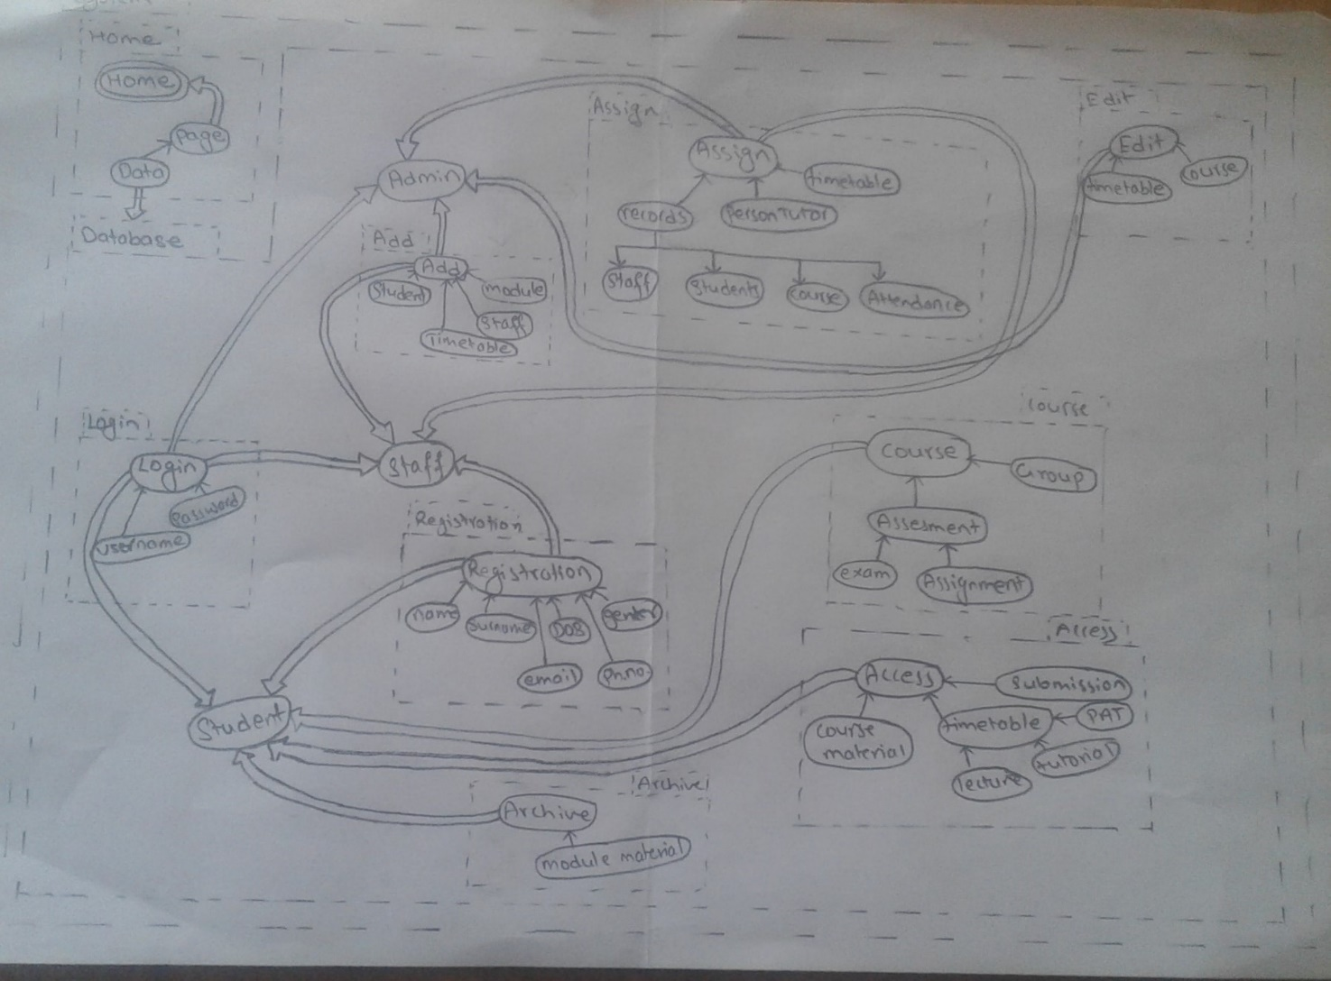

*Fig: showing BON diagram*

|  |  |  |  |
| --- | --- | --- | --- |
| **CLUSTER** | User | | **Part:1/1** |
| **PURPOSE:** co-operating the structure of the system with the authorization. | | **INDEXING:**  Author: Anup Thapa | |
| **Class/(Cluster)** | | **Description** | |
| Admin | | Acting as the role model who has all the authorities of institution like adding, modifying, deleting, editing the records of students, and staff and performs the other declared functions. | |
| Students | | An active role in the university. | |
| Staff | | Carries the activities like keeping records of students, assignment management, timetable and other functions of managing course and tutor. | |
| Ex-students | | Can access the study materials and see the submitted details on the screen. | |

### BON Cluster Charts

|  |  |  |  |
| --- | --- | --- | --- |
| **CLUSTER** | User Interface | | **Part:1/1** |
| **PURPOSE:** the user enters to the interface where he/she can login to go through the system. | | **INDEXING**  Author: Anup Thapa | |
| **Class/(Cluster)** | | **Description** | |
| Academic website | | The page where all the valuable information are stored. | |
| Login | | The location where the user get access to system. | |
| Navigation bar | | User can select the given option for the information after the login process. | |

|  |  |  |  |
| --- | --- | --- | --- |
| **CLUSTER** | User Database | | **Part:1/1** |
| **PURPOSE:** handling all the records who are involved in the academic activities | | **INDEXING**  Author: Anup Thapa | |
| **Class/(Cluster)** | | **Description** | |
| Staff records | | Complete details of staff academic performance. | |
| Students records | | Complete details of student. | |
| Course records | | Complete information of the administration | |
| Attendance records | | The detail of the attendance of students and staff. | |
| Ex- students records | | The full information of the pass out students. | |

|  |  |  |  |
| --- | --- | --- | --- |
| **CLUSTER** | Announcement | | **Part:1/1** |
| **PURPOSE:** updating the students about the academic behaviors. | | **INDEXING:** | |
| **Class/(Cluster)** | | **Description** | |
| Assignment / TCA/Mock-exam | | Provided by the module leaders . | |
| Attendance | | The notification for the student about their attendance. | |
| Grades | | The marking for the submitted assignment. | |
| Academic functions | | The other notification that are related with the module or courses or any other extra curriculum activities related to institution. | |

|  |  |  |  |
| --- | --- | --- | --- |
| **CLUSTER** | Reports | | **Part:1/1** |
| **PURPOSE:** complete description of the students who are enrolled in the university | | **INDEXING:**  Author: Anup Thapa | |
| **Class/(Cluster)** | | **Description** | |
| Exam | | Record of the students who have attended the exam. | |
| Attendance | | The record related to the attendance of the students. | |

|  |  |  |  |
| --- | --- | --- | --- |
| **CLUSTER** | News | | **Part:1/1** |
| **PURPOSE:** notice for the students that are provided by the module leaders | | **INDEXING:**  Author: Anup Thapa | |
| **Class/(Cluster)** | | **Description** | |
| Feedback | | Report about the performance in the academic behavior of students | |

### BON Class Charts:

|  |  |  |  |
| --- | --- | --- | --- |
| **Class** | Admin | | **Part:1/1** |
| **Type of object:** admin in the organization | | **INDEXING:**  Author: Anup Thapa | |
| **Queries** | | admin_id, admin_name, admin_password | |
| **Commands** | | Create, Amend, Archive, Display, Assign, Print, Search, update. | |
| **Constraints** | | * The written queries cannot be null. * Must be joined at the university * Id number is assigned at creation, numbers auto-increment and are never recycled. | |

|  |  |  |  |
| --- | --- | --- | --- |
| **Class** | Students | | **Part:1/1** |
| **Type of object:** student enroll on the course | | **INDEXING:**  Author: Anup Thapa | |
| **Queries** | | student_id, student_firstname, student_surname, student_dob, student_address, student_contact, student_gender, email, level, student_photo . | |
| **Commands** | | Create, Amend, Archive, Display, Assign, Print, Search | |
| **Constraints** | | * Student_id, Name, Surname, Address, and Contact number cannot be null. * Must be joined at the university * Id number is assigned at creation, numbers auto-increment and are never recycled. * Must be assigned at least one course. | |

|  |  |  |  |
| --- | --- | --- | --- |
| **Class** | Staff | | **Part:1/1** |
| **Type of object:** staff member of the organization | | **INDEXING:**  Author: Anup Thapa | |
| **Queries** | | Staff_id, staff_name, staff_surname, staff_dob, staff_address, staff_contact, staff_gender, hireDate, qualification, staff_photo. | |
| **Commands** | | Create, Amend, Archive, Display, Assign, Print, Search | |
| **Constraints** | | * Staff_id, Name, Surname, Address, job title and Contact number cannot be null. * Must be joined at the university * Id number is assigned at the start of employment, numbers auto-increment and are never recycled. * Must have student assigned to them * Must join at least one course | |

|  |  |  |  |
| --- | --- | --- | --- |
| **Class** | Courses | | **Part:1/1** |
| **Type of object:** course run by university | | **INDEXING:**  Author: Anup Thapa | |
| **Queries** | | course_id, staff-id, admin_id, course_name, course_leader | |
| **Commands** | | Create, Amend, Archive, Display, Delete | |
| **Constraints** | | * The id for the course should be unique and not null. * Students cannot be attached with more than one course. * A teaching staff should be included to course. * Staff_id, admin_id as foreign key. * A course leader should be appointed. | |

|  |  |  |  |
| --- | --- | --- | --- |
| **Class** | Modules | | **Part:1/1** |
| **Type of object:** module in the organization | | **INDEXING:**  Author: Anup Thapa | |
| **Queries** | | Module_id , module_name, staff_id, admin_id, module_leader, course_id | |
| **Commands** | | Create, Amend, Archive, Display, Delete, edit | |
| **Constraints** | | * The module id must be unique. * Module leader must be appointed. * A module is assigned with at least one or more than one courses. * Staff_id, admin_id, course_id acting as foreign key. | |

## Detailed Dynamic System Designs

### Event Charts

??

### Object creation Charts

??

### System Scenario Charts

??

### Dynamics Diagram

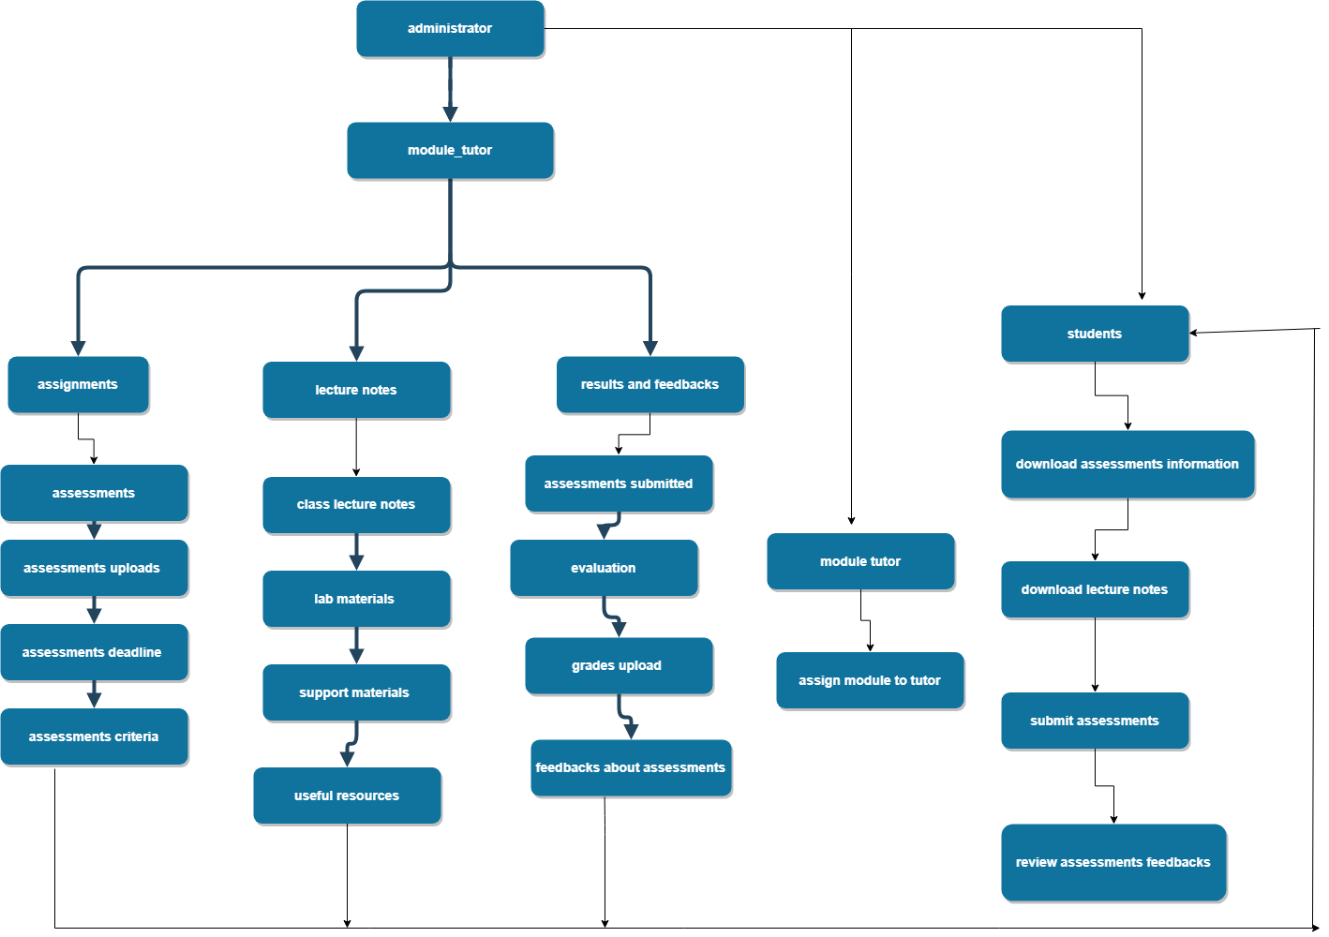

*Fig 6. Showing dynamics diagram*

## System Database Design

System database design is collection of processes that organize data according to database model. It helps to manage, development implement the functionality of data. Whole together the system is produced in the behalf of the user. The system is physically presented but logically implemented in the schema of every database. System design helps to reduce data redundancies and data integrity.

### E-R Model

Here is the Entity Relationship model of the project.

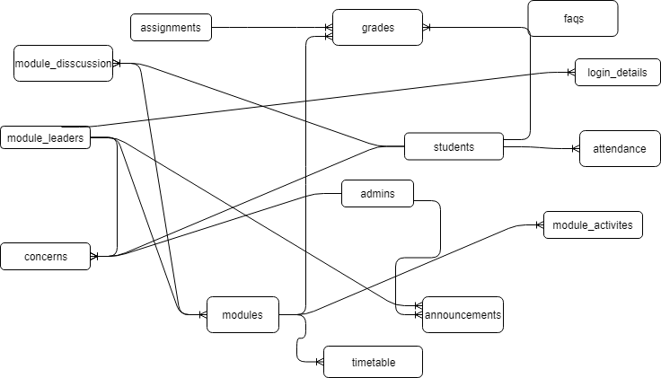

*Fig: showing E-R model*

Attribute listings

|  |  |  |  |  |  |
| --- | --- | --- | --- | --- | --- |
| S.N | Attribute | Datatype | Constraint | default | AUTO_INCREMENT |
| admins | | | | | |
| 1 | admin_id | NUMBER(11) | P.K | NOT NULL | A.I |
| 2. | admin_name | VARCHAR2(225) |  |  |  |
| 3. | admin_password | VARCHAR2(225) |  |  |  |
| anouncements | | | | | |
| 1. | ano_id | NUMBER(11) | P.K | NOT NULL | A.I |
| 2. | ano_title | VARCHAR2(225) |  |  |  |
| 3. | ano_details | VARCHAR2(225) |  |  |  |
| 4. | ano_date | DATE |  |  |  |
| 5. | admin_id | NUMBER(11) | F.K | NULL |  |
| 2. | staff_id | NUMBER(11) |  | NOT NULL |  |
| 3. | ano_archive | NUMBER(1) |  | 1 |  |
| assignments | | | | | |
| 1. | assignment_id | NUMBER(11) | P.K |  | A.I |
| 2. | assignment_name | VARCHAR2(225) |  |  |  |
| 3. | assignment_file | VARCHAR2(225) |  |  |  |
| 4. | Module_id | NUMBER(11) | F.K |  |  |
| 5. | details | VARCAHR(225) |  |  |  |
| 6. | Issue_details | DATE |  |  |  |
| 7. | due_date | DATE |  |  |  |
| 8. | approve | NUMBER(11) |  |  |  |
| attendences | | | | | |
| 1. | student_id | NUMBER(11) | P.K/F.K |  |  |
| 2. | module_id | NUMBER(11) | P.K/F.K |  |  |
| 3. | week1 | NUMBER(3) |  |  |  |
| 4. | week2 | Number(3) |  |  |  |
| 5. | week3 | Number(3) |  |  |  |
| 6. | week4 | Number(3) |  |  |  |
| 7. | week5 | Number(3) |  |  |  |
| 8. | week6 | Number(3) |  |  |  |
| 9. | week7 | Number(3) |  |  |  |
| 10. | week8 | Number(3) |  |  |  |
| 11. | week9 | Number(3) |  |  |  |
| 12. | week10 | Number(3) |  |  |  |
| 13. | week11 | Number(3) |  |  |  |
| 14. | week12 | Number(3) |  |  |  |
| 15. | totaldays | NUMBER(3) |  |  |  |
| concerns | | | | | |
| 1. | conc_id | NUMBER(3) | P.K | NOT NULL | A.I |
| 2 | conc_title | VARCAHR2(225) |  |  |  |
| 3. | conc_details | TEXT |  |  |  |
| 4. | student_id | NUMBER(11) | F.K | NULL |  |
| 5. | staff_id | NUMBER(11) | F.K | NULL |  |
| 6. | admin_id | NUMBER(11) | F.K | NULL |  |
| faqs | | | | | |
| 1. | faq_id | NUMBER(11) | P.K | NOT NULL | A.I |
| 2. | faq_ques | VARCHAR(225) |  |  |  |
| 3. | faq_ans | VARCHAR(225) |  |  |  |
| 4. | ignore_ques | VARCHAR2(225) |  |  |  |
| gardes | | | | | |
| 1. | grade_id | NUMBER(11) | P.K | NOT NULL | A.I |
| 2. | grades | VARCHAR2(225) |  |  |  |
| 3. | module_id | NUMBER(11) | F.K | NULL |  |
| 4. | student_id | NUMBER(11) | F.K | NULL |  |
| 5. | assignment_id | NUMBER(11) | F.K | NULL |  |
| 6. | grade_file | VARCHAR2(255) |  |  |  |
| 7. | submit_status | NUMBER(1) |  | NULL |  |
| login_details | | | | | |
| 1. | login_id | NUMBER(11) | P.k | NOT NULL | A.I |
| 2. | login_email | VARCHAR(255) |  |  |  |
| 3. | login_password | VARCHAR(65) |  |  |  |
| 4. | user_type | VARCHAR(255) |  |  |  |
| 5. | user_id | NUMBER(11) |  |  |  |
| 6. | I_archive | NUMBER(1) |  |  |  |
| modules | | | | | |
| 1. | module_id | NUMBER(11) | P.K | NOT NULL | A.I |
| 2. | module_name | VARCHAR(255) |  |  |  |
| 3. | module_level | VARCHAR(255) |  |  |  |
| 4. | exam_sturcture | VARCAHR(255) |  |  |  |
| 5. | merits_points | VARCHAR(255) |  |  |  |
| 6. | staff_id | NUMBER(11) | F.k | NOT NULL |  |
| 7. | m_archive | NUMBER(11) |  |  |  |
| module_activites | | | | | |
| 1. | mda_id | NUMBER(11) | P.K | NOT NULL | A.I |
| 2. | mda_title | VARCHAR(225) |  |  |  |
| 3. | mda_desc | VARCHAR(255) |  |  |  |
| 4. | mda_file | VARCHAR(255) |  |  |  |
| 5. | module_id | NUMBER(11) | F.K |  |  |
| Module_disscussion | | | | | |
| 1. | discus_id | NUMBER(11) | P.K | NOT NULL | A.I |
| 2. | module_id | NUMBER(11) | F.K |  |  |
| 3. | student_id | NUMBER(11) | F.K |  |  |
| 4. | question | VARCHAR2(255) |  |  |  |
| 5. | answer | VARCAHR(255) |  |  |  |
| module_leaders | | | | | |
| 1. | staff_id | NUMBER(11) | P.K | NOT NULL | A.I |
| 2. | staff_firstname | VARCAHR(255) |  |  |  |
| 3. | staff_surname | VARCHAR(255) |  |  |  |
| 4. | staff_dob | DATE |  |  |  |
| 5. | staff_address | Varchar(255) |  |  |  |
| 6. | staff_contact | VARCHAR(15) |  |  |  |
| 7. | staff_email | VARCHAR(255) |  |  |  |
| 8. | staff_gender | CHAR(1) |  |  |  |
| 9. | hire_date | DATE |  |  |  |
| 10. | qualification | VARCHAR(255) |  |  |  |
| 11. | staff_photo | VARCAHR(255) |  |  |  |
| 12. | staff_password | VARCAHR(255) |  |  |  |
| 13. | leader_archive | NUMBER(11) |  |  |  |
| 14. | staff_type | NUMBER(1) |  |  |  |
| students | | | | | |
| 1. | student_idPrimary | NUMBER(11) | P.K | NOT NULL | A.I |
| 2. | student_firstname | VARCAHR(255) |  |  |  |
| 3. | student_surname | VARCAHR(255) |  |  |  |
| 4 | student_dob | DATE |  |  |  |
| 5 | student_address | VARCHAR(255) |  |  |  |
| **6.** | **student_contact** | VARCHAR(255) |  |  |  |
| 7. | student_gender | CAHR(1) |  |  |  |
| 8 | student_email | VARCHAR(255) |  |  |  |
| 9. | level | VARCHAR(255) |  |  |  |
| 10 | student_photo | VARCHAR(255) |  |  |  |
| 11 | **modules** | VARCHAR(255) |  |  |  |
| 12. | **s_archive** | NUMBER(1) |  |  |  |
| Timetable | | | | | |
| 1. | timetable_id | NUMBER(11) | P.K | NOT NULL | A.I |
| 2. | Module_id | NUMBER(11) |  |  |  |
| 3. | Date | DATE |  |  |  |
| 4. | time | TIME |  |  |  |
| 5. | class_no | NUMBER(11) |  |  |  |
| 6. | Session_type | VARCHAR(255) |  |  |  |

*3.4.2 Attribute Listings*

# System Interface Designs

## Draft Interface Designs

### Wireframes

Wireframes of homepage:

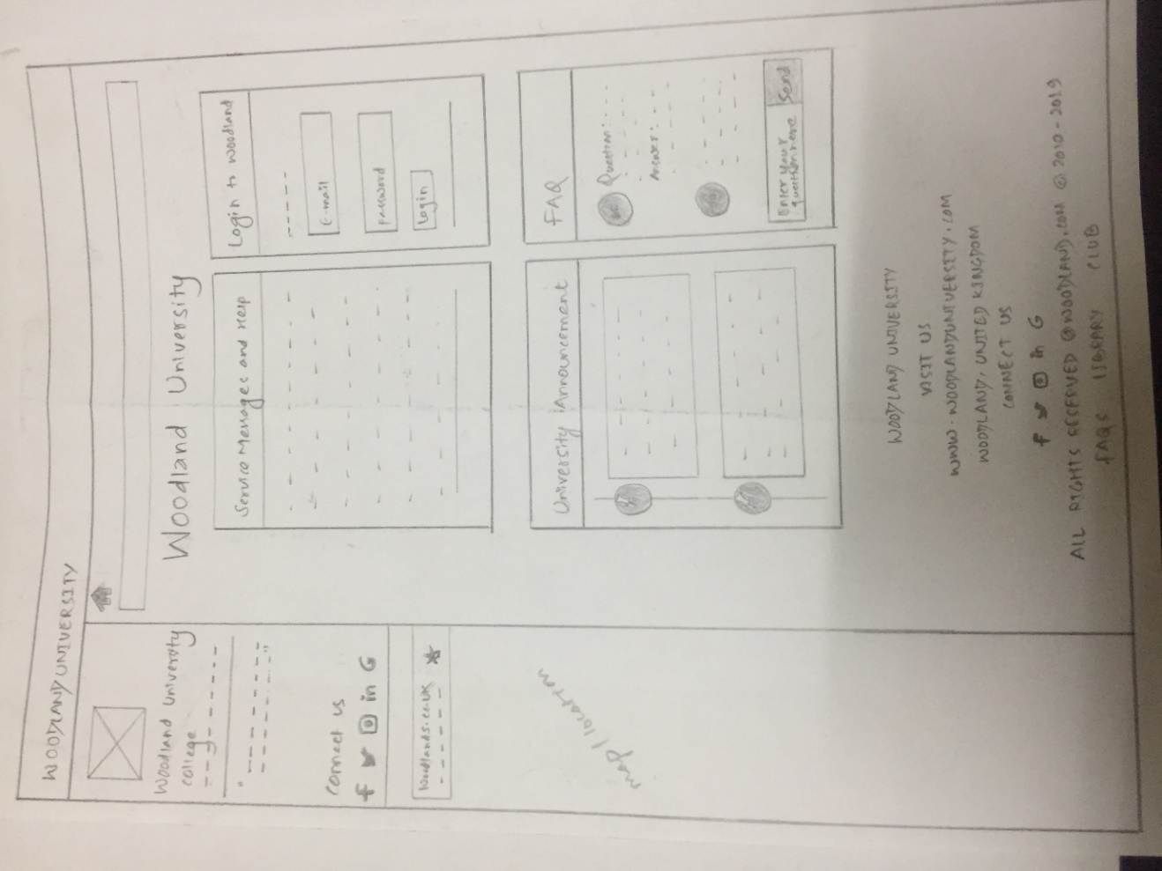

*Fig: home page*

The above is the wire frame for the home page for admin, staff and students. This is to be the initial state for the system where all the member can login with their email and password and go to their respective home page and perform the tasks. The home page contains media connectivity, map on the left side, the login and announcements on main section.

**Wireframe of Admin page:**

Admin home page:

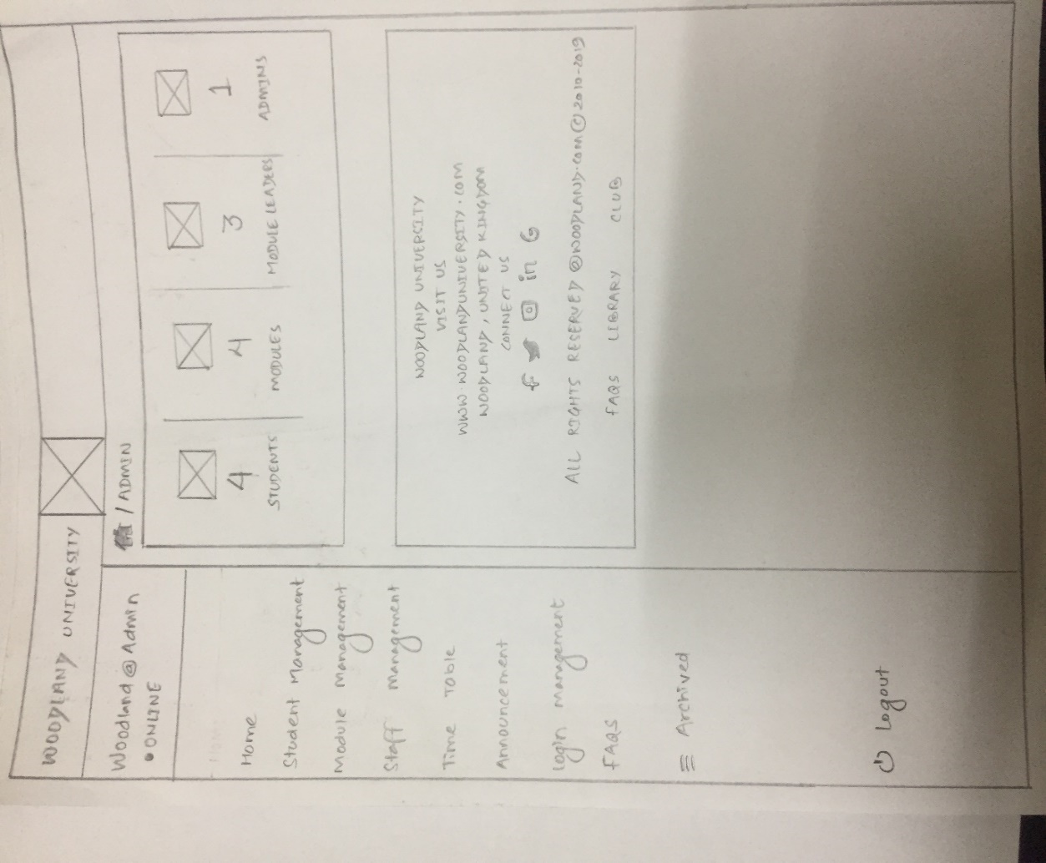

*Fig: admin page*

The above wireframe is of admin home page. This home page is shown when the admin enters the correct email and password in the login form. The home page of admin contains the database status, footer and the authority to add, delete, update the students, staff, module, time- table and FAQS.

Student Management:

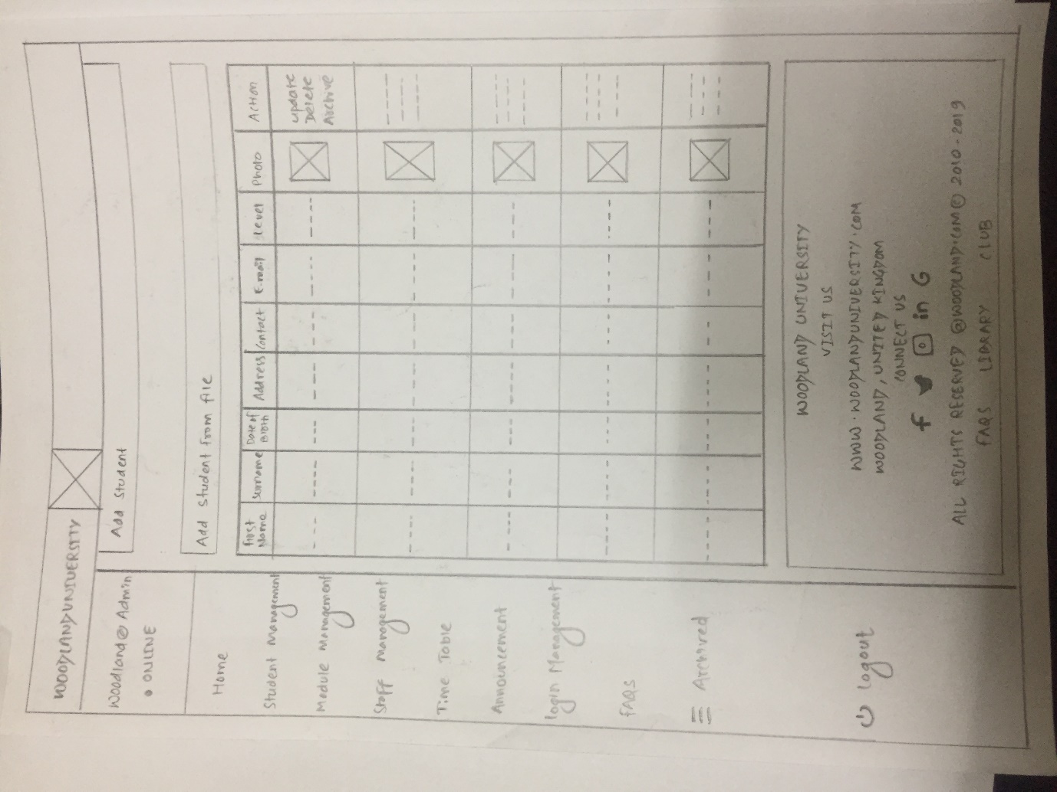

*Fig: student management*

The above wire frame is of staff management where admin can add the record of staff, delete them and also can update. The records are shown on the tabular form.

Module Management:

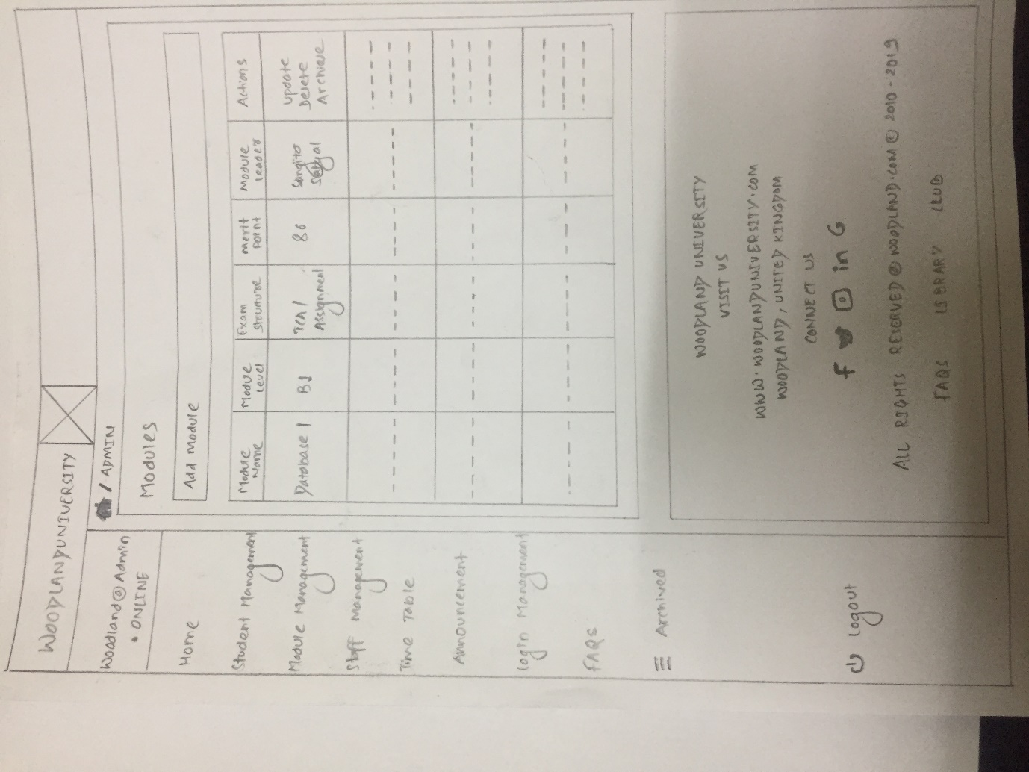

*Fig: Module Management*

The above wireframe is of module management where the admin can add modules. The added modules are shown in tabular form. The table has got actions which has values to update, delete or acrchive.

Staff Management:

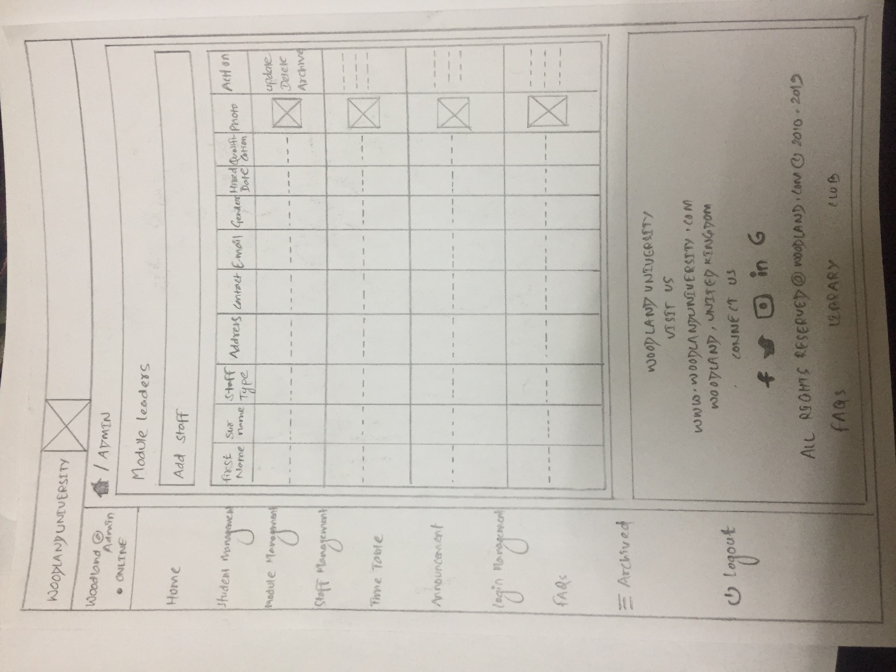

*Fig: Staff Management*

The above wireframe is for module management which will contain the list of all module data in tabular form. The link ‘Add staff’ will contain the form which helps to add the information related to module.

Time Table:

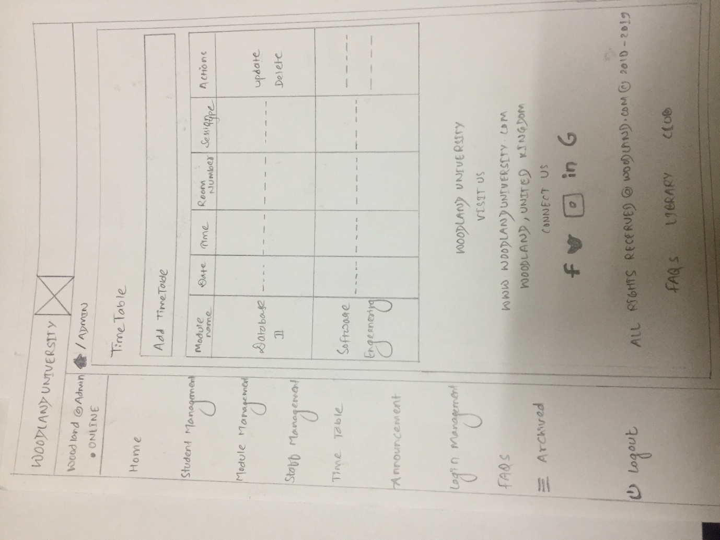

*Fig: Time Table Management*

Announcement:

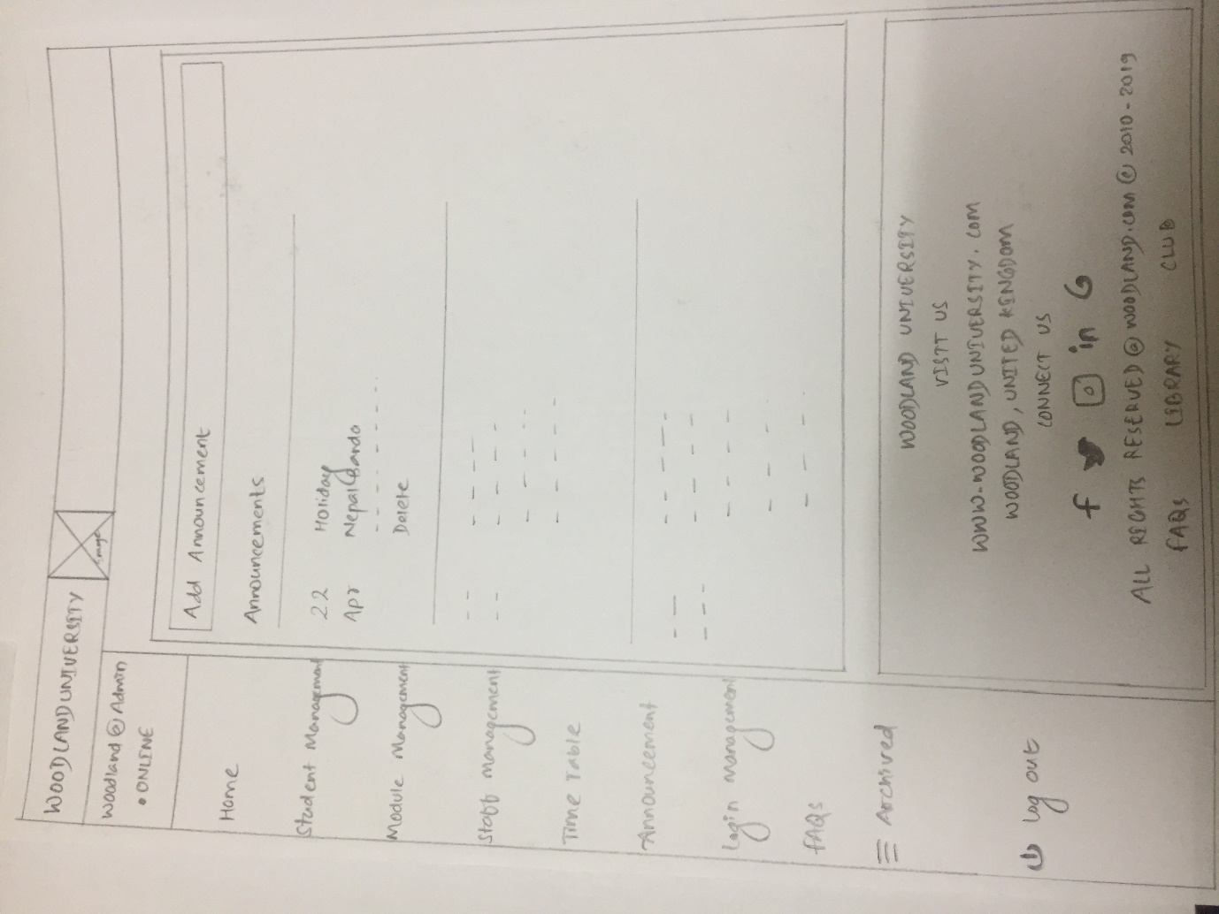

*Fig: Announcement Management*

Login Management:

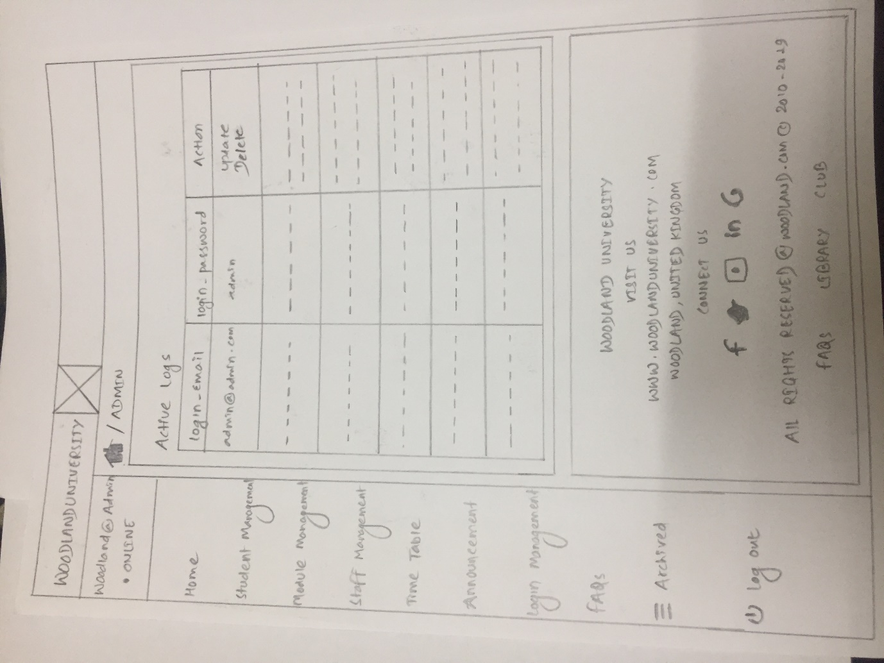

*Fig: Login Management*

FAQs:

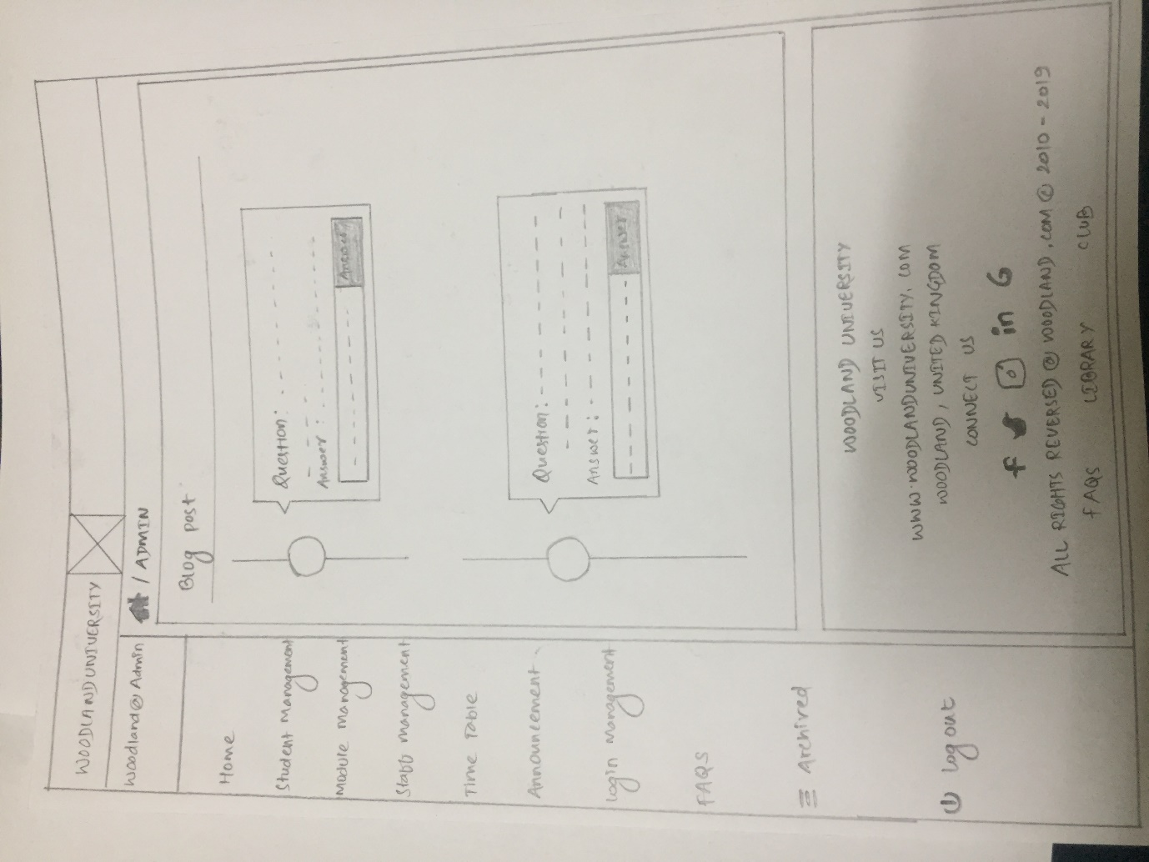

*Fig: FAQs management*

Wireframe of student page

Home page:

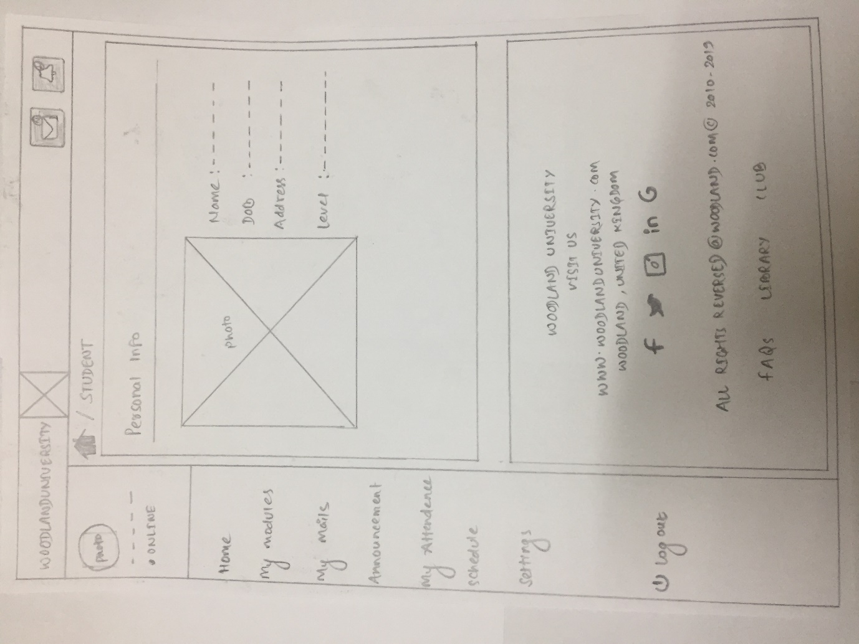

Fig: Student Home Page

Modules:

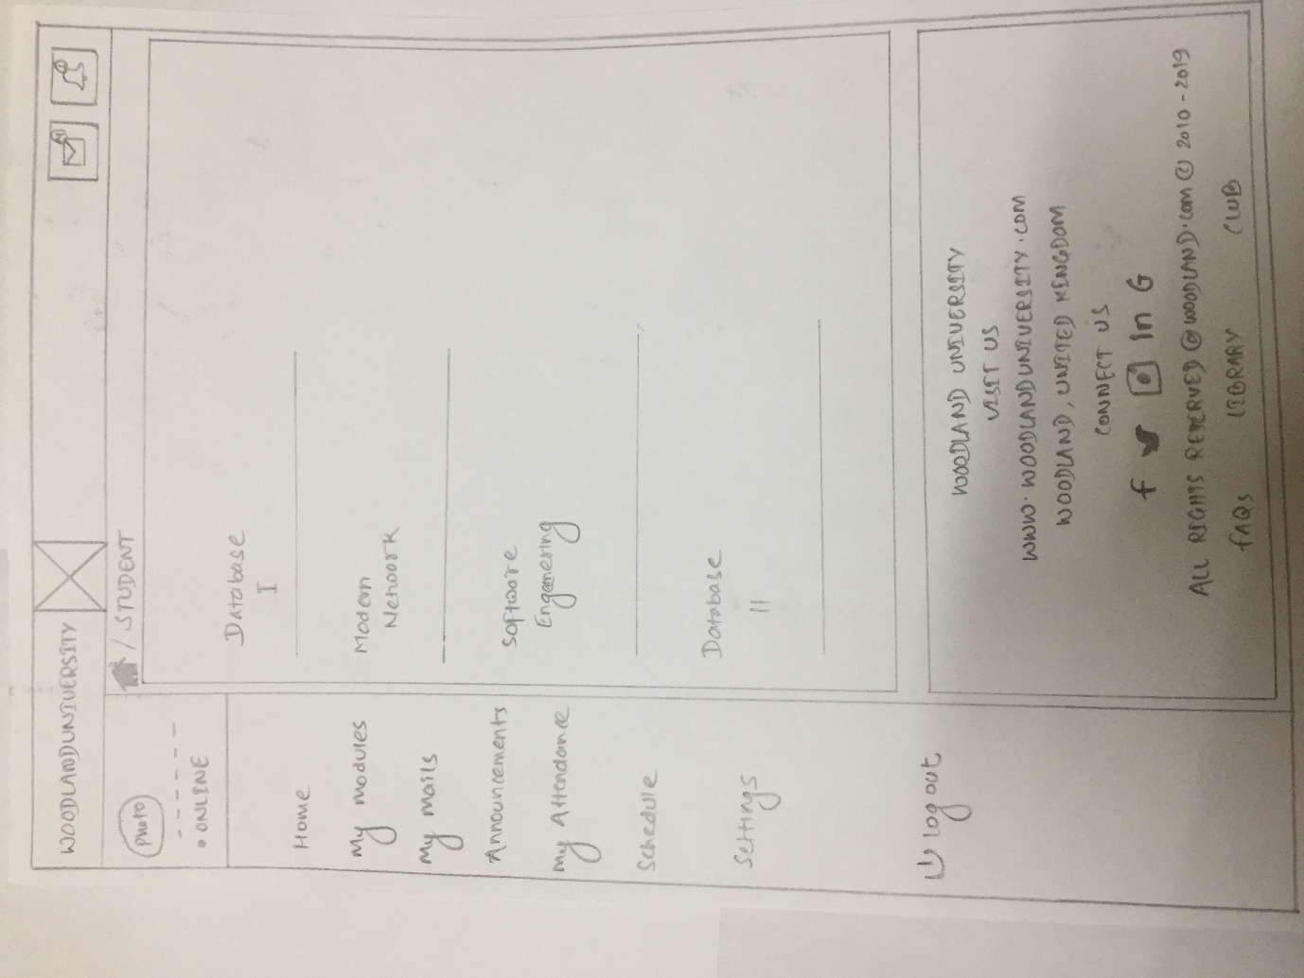

Fig : Student Module Page

Mails:

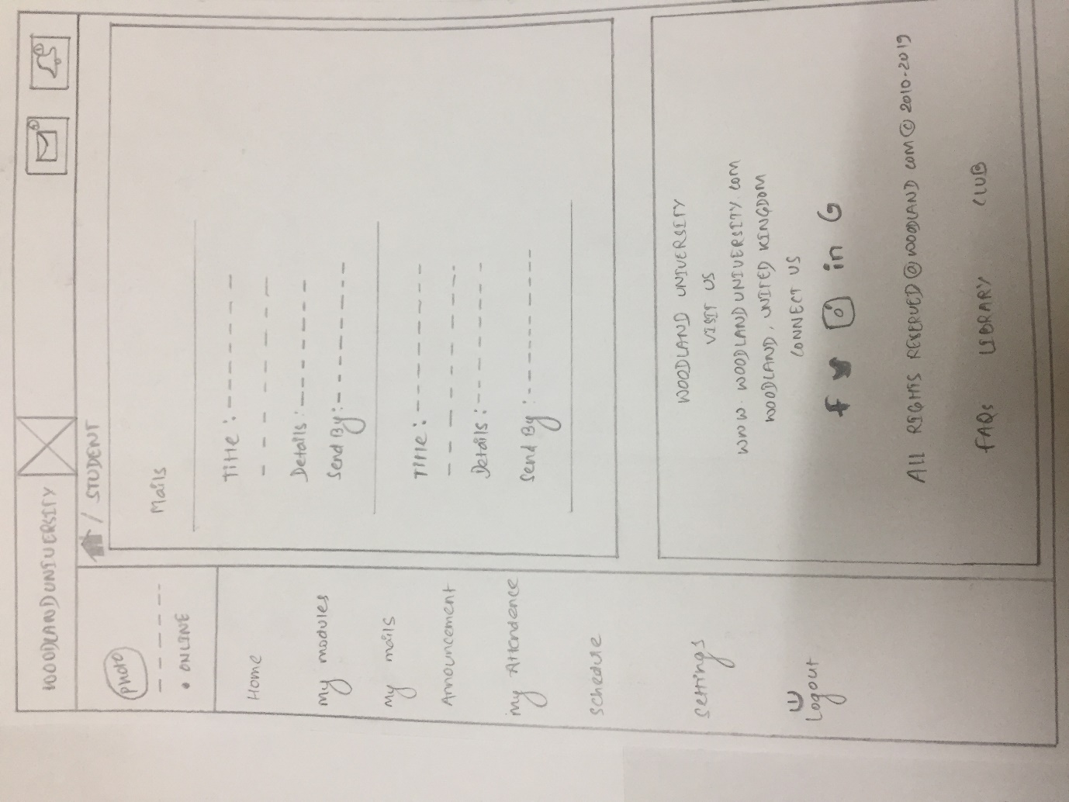

*Fig: Student mail page*

Announcement:

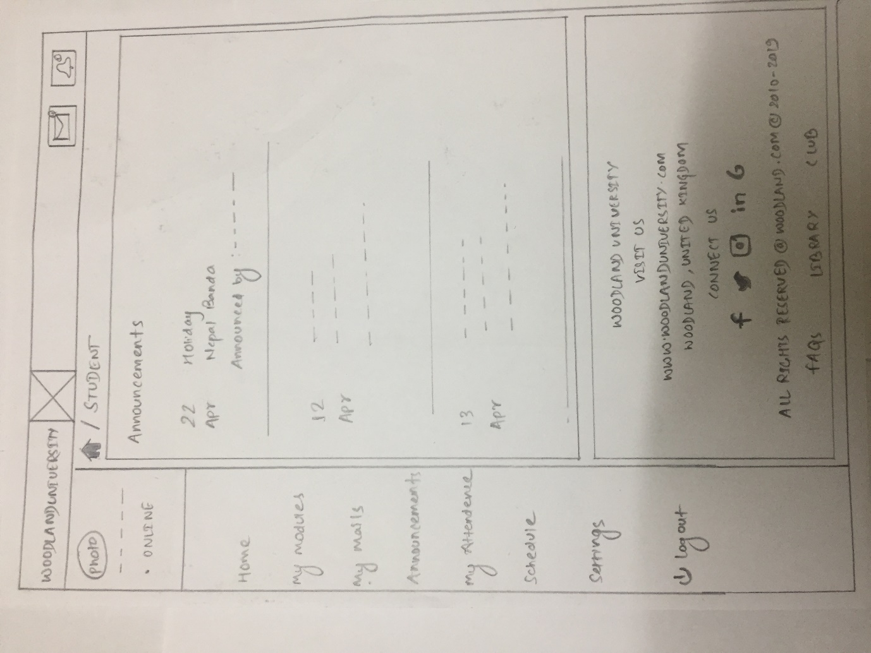

*Fig: Student announcement view page*

Attendance:

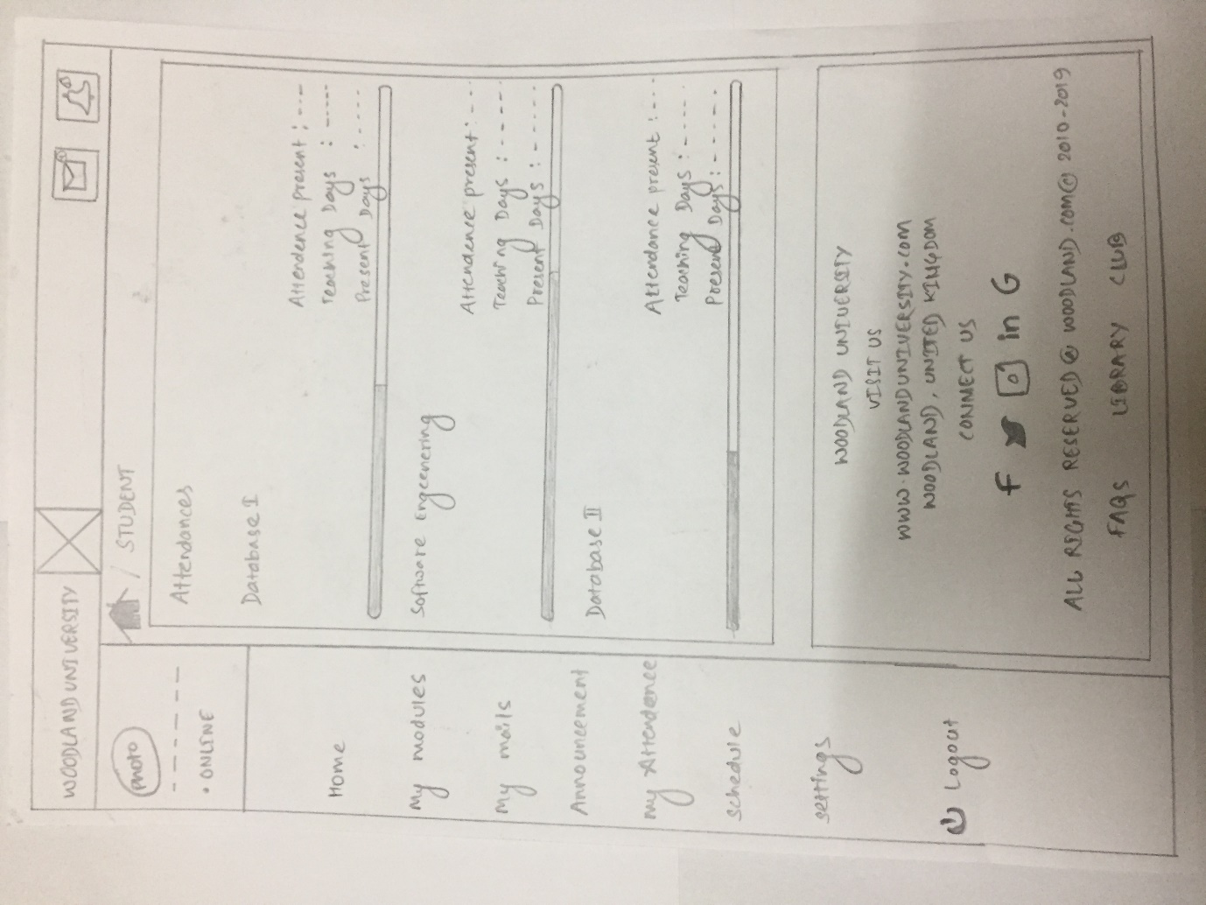

*Fig: Student attendance view page*

Schedule:

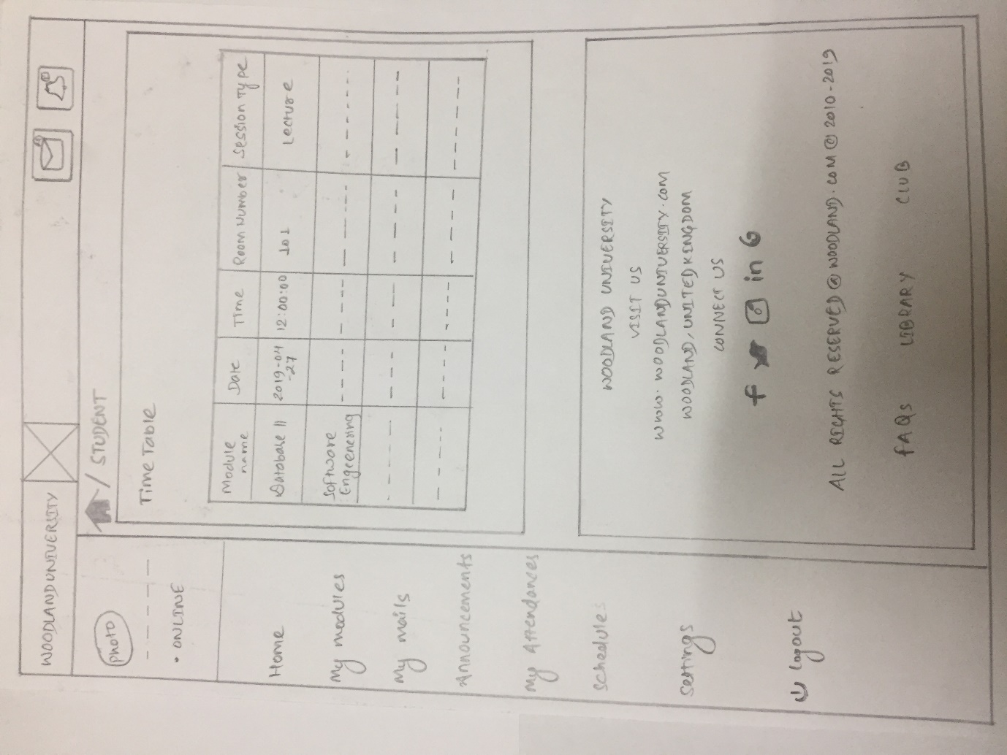

Fig: Student Schedule Page

### System Navigation Diagram

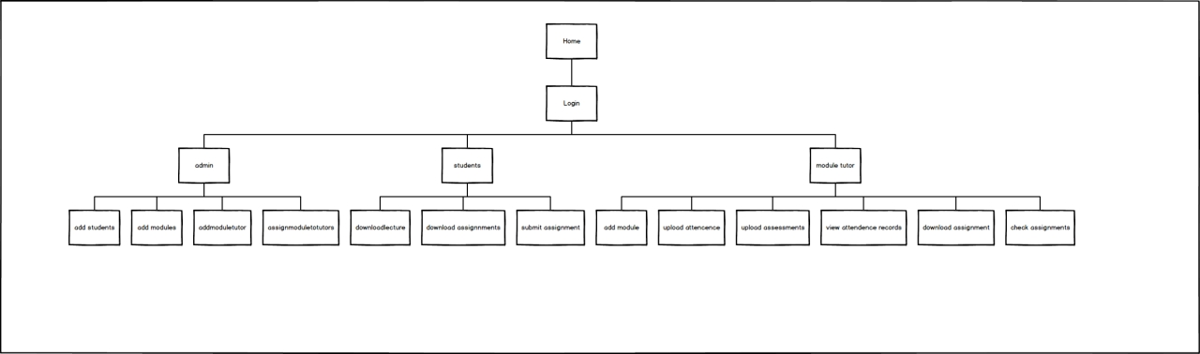

*Fig: Navigation login*

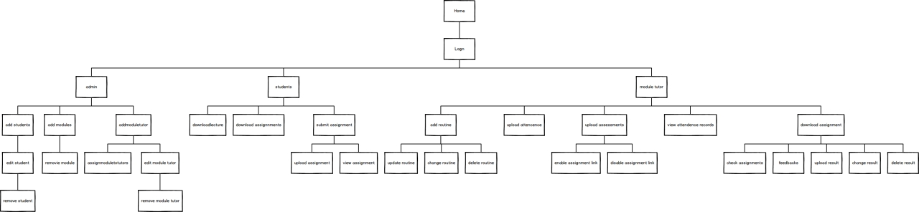

*Fig: Navigation home*

### System Screen Mock-ups

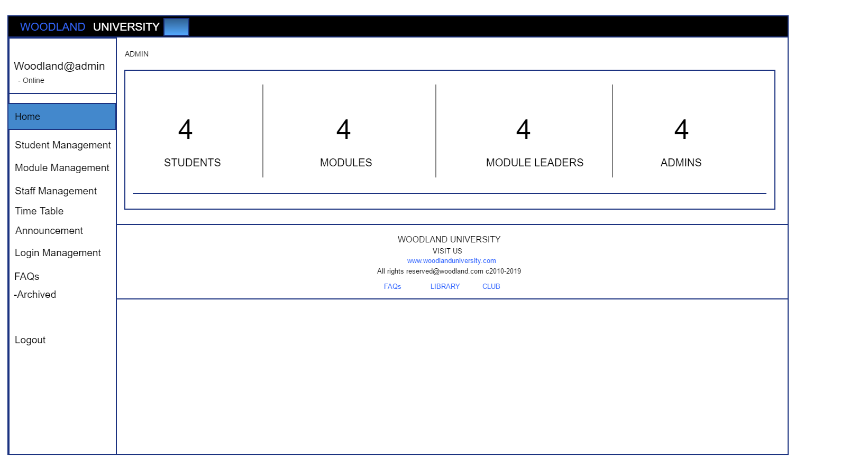

*Fig: Admin Home*

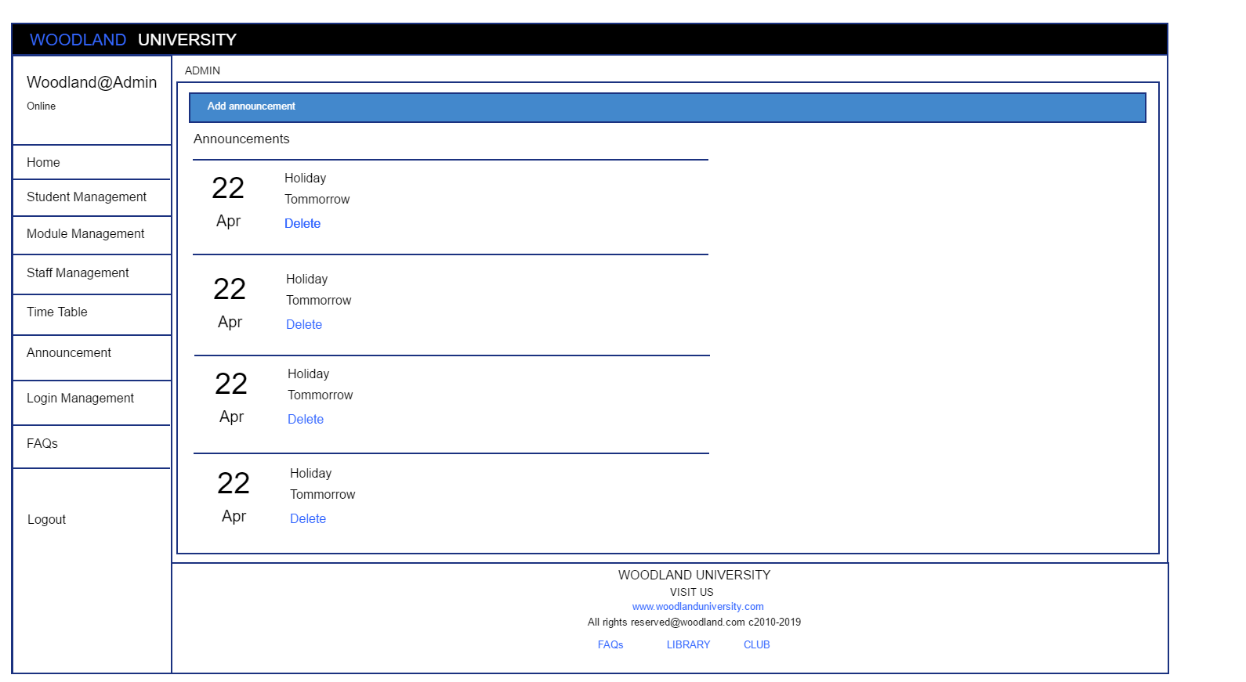

*Fig: Announcement Management*

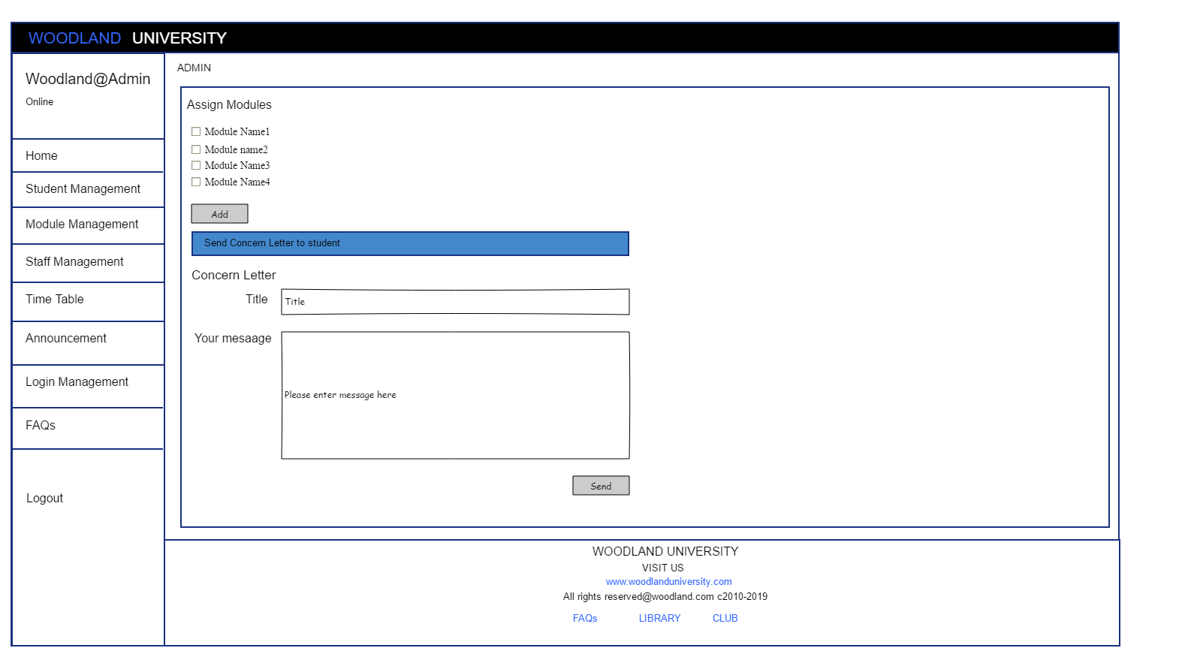

*Fig: Assign Module*

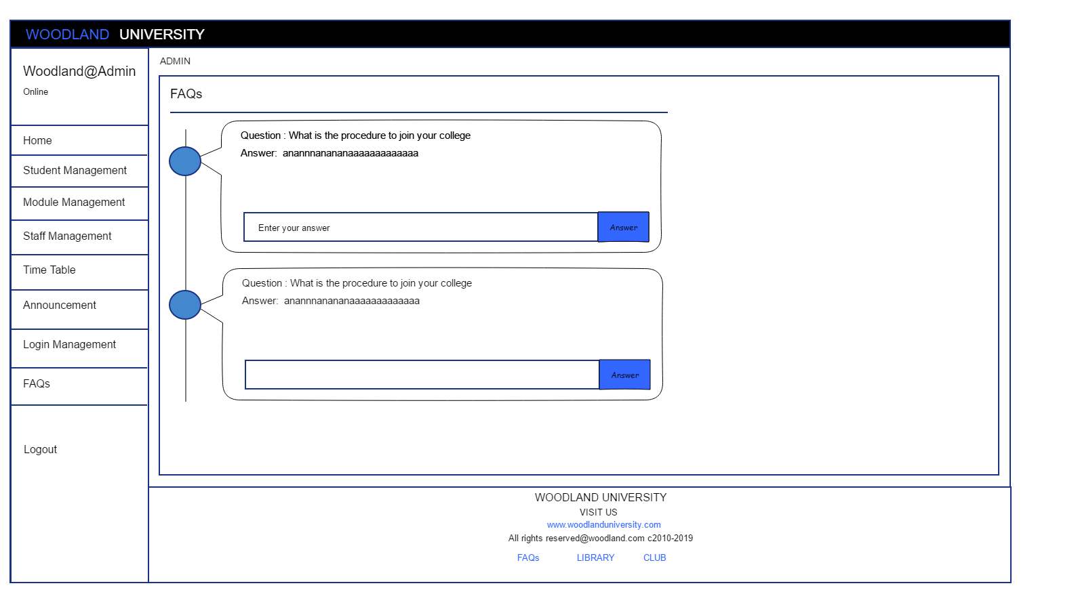

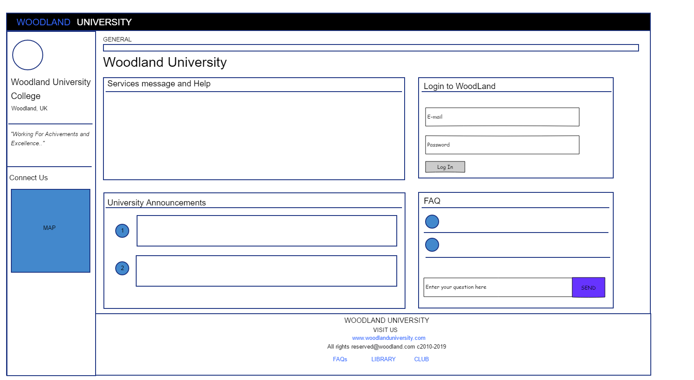

*Fig: Homepage*

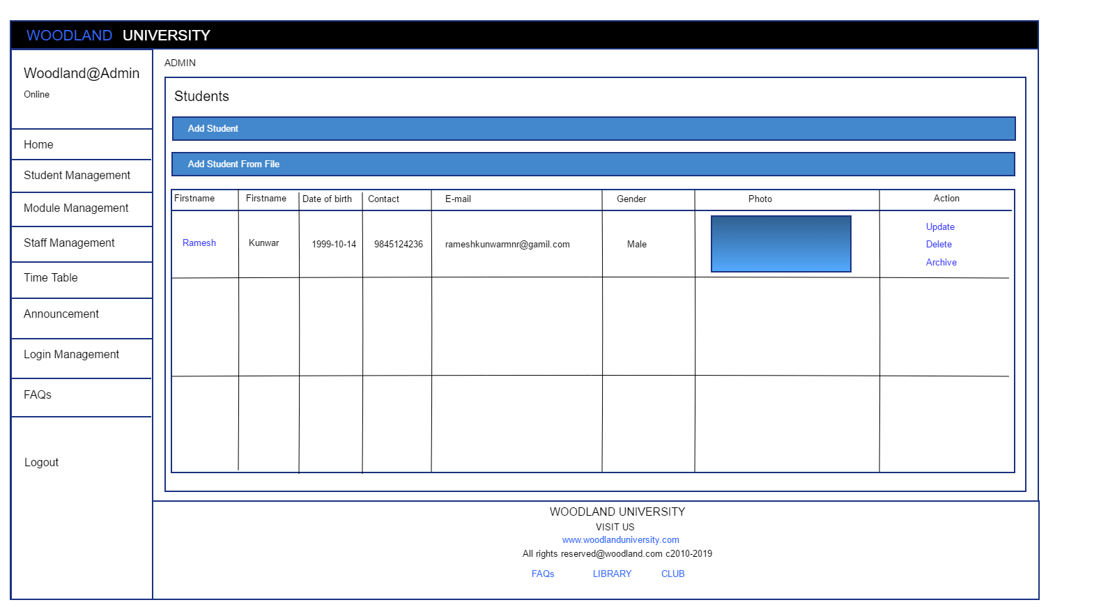

*Fig: Student Management*

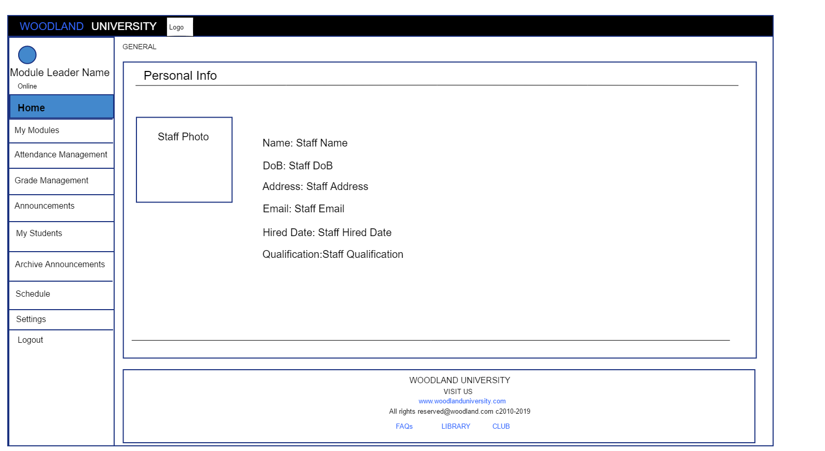

*Fig: Module Leader home*

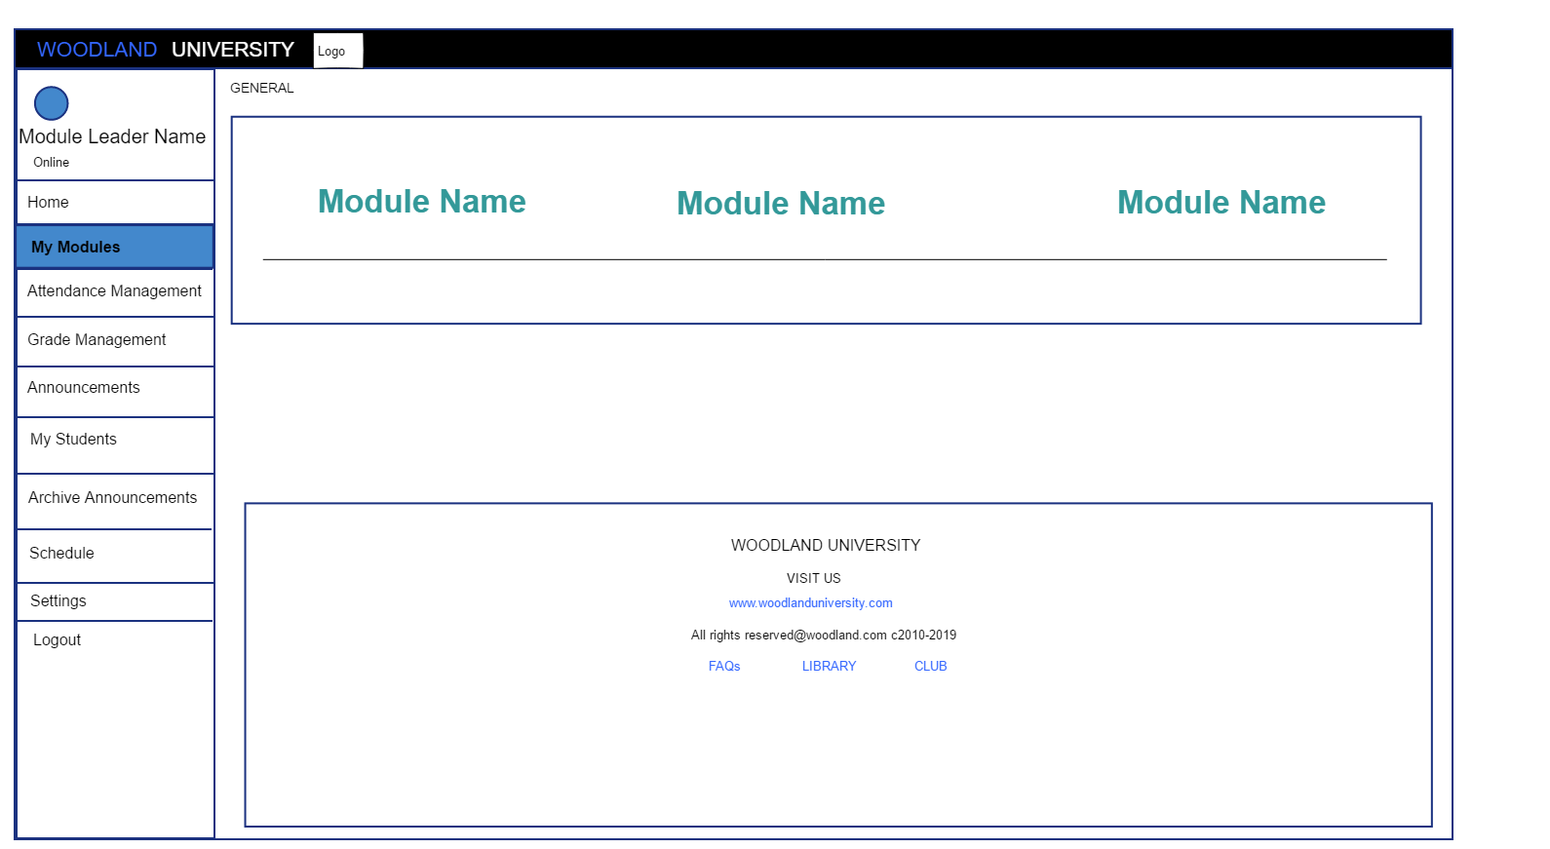

*Fig: Module leader module view*

## Design Revision

## Heuristic Evaluation

The following usability criteria have been assessed in an attempt to evaluate the suitability of provisional system designs against established good design principles.

Conformity Key

1 = Conforms in all parts.

2 = Conforms in most parts.

3 = Conforms in some parts.

4 = Does not conform.

|  |  |  |  |
| --- | --- | --- | --- |
| **Usability Criteria (Heuristics)**  **Appropriate use of:** | **Level of Conformity**  **(1-4)** | **Evidence/Examples of application** | **Additional Comments/Issued Raised** |
| **Metaphors** | **3** | **Nile, evision** | **No issues** |
| **Consistency/**  **Perceived Stability** | **3** | **Nile** | **No issues** |
| **WYSIWYG** | **3** | **Nile, evision** | **No issues** |
| **User Centred**  **Control** | **4** | **Nile, evision** | **No issues** |
| **Feedback and Dialog** | **3** | **Nile, evision** | **No issues** |
| **Forgiveness** | **3** |  | **No issues** |
| **Interface Text** | **4** | **Nile, evision** | **No issues** |
| **Buttons** | **4** | **Nile, evison** | **No issues** |
| **Icons** | **4** | **Nile, evision** | **No issues** |
| **Colour** | **4** | **Nile, evision** | **No issues** |
| **Modelessness** | **4** | **Nile, evision** | **No issues** |

# System Build and Technical Notes

While developing the project for woodland university, we made use of several methods of implementations and interface designs.

## Technically Difficult Code Selections

The main programming language we selected for the development of the project is PHP and for the database use used SQL in phpMyAdmin. The main tough decision was to select the appropriate programming language to implement the project. After the series of the group meeting and discussion we came at the point where we decided to use PHP as the developing language.

After the selection of appropriate programming language, the main difficulty was to finalize design and mode of implementation in project. We were confused somewhere to develop own html CSS layout or use the template form third party organizations. At the last we decided to use the template form from medialoot.com. They provide wide variety of templates from bootstrap and many other sides.

After that we used MVC form to develop the project to insure the future development of the project safe. During this time all the basic design and implementation ideas were finalized, and few members of the group started coding.

In the coding part, we have made use of all the basic and necessary elements of the core PHP. Database handling was awesome work and the main difficulty arrives when we tried to implement the student admission and attendance process, we faced some serious problems because the plan was to insert students and attendance in the database through spreadsheet file like CVS, excel file. To code this section, we take a little more time in comparison to other parts of development.

## On-going Testing Methodology

During the implementation phase, one of our group members was testing all the functionality and providing appropriate results if the test. To test the code quality and efficiency, we made the use of Blackbox testing and White box testing including the Walkthrough process. All the functionality was tested several times and found some errors and bugs. Those bugs and errors were removed after the testing of the project.

## Final System Interface Displays

After the moths of group discussion, implementation and testing evaluation, the outcome of system interface was quite satisfactory. Following are some images of the final system interface.

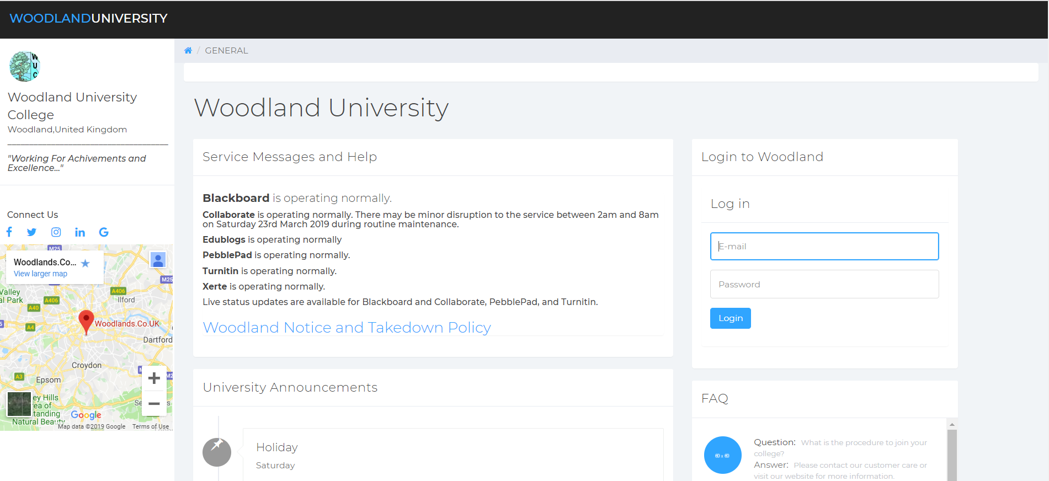

*Fig: Home page cum login page*

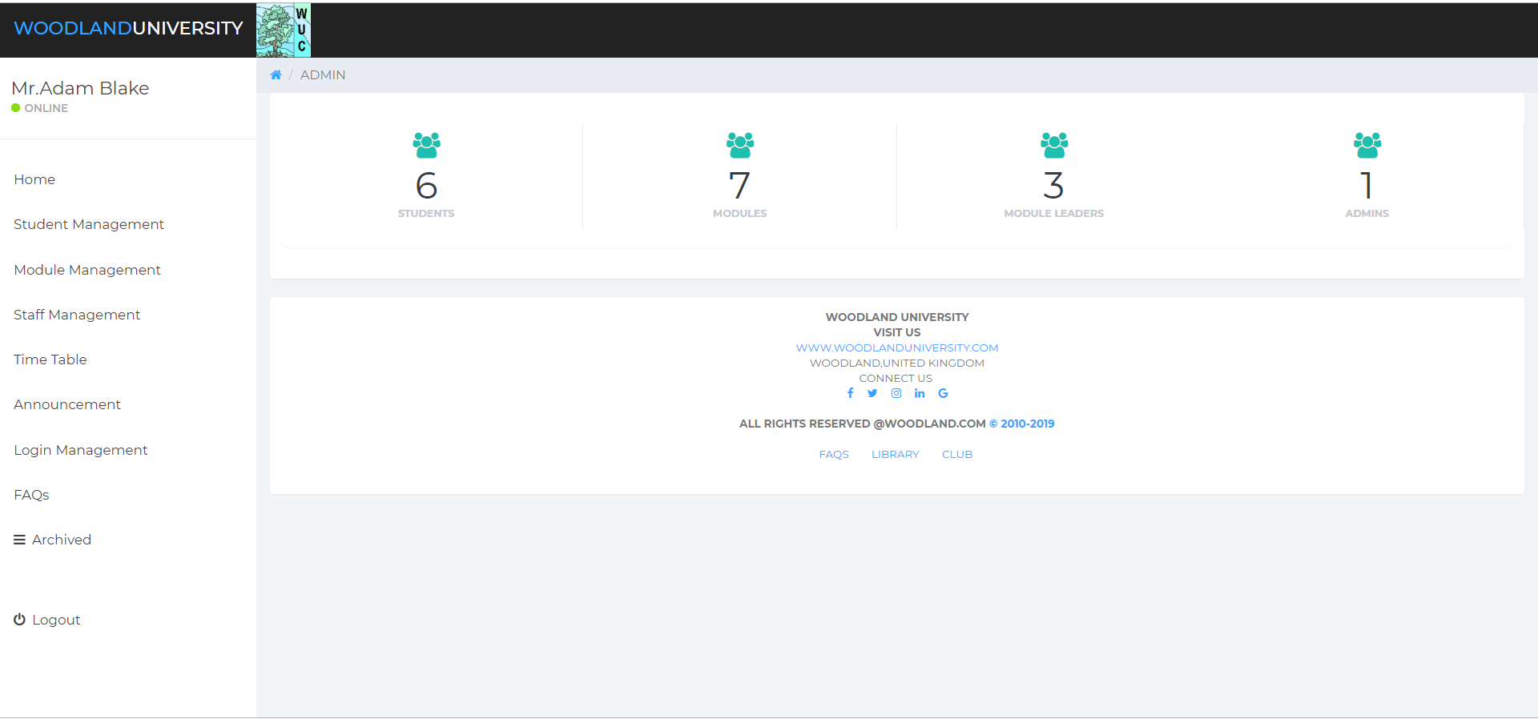

*Fig: Admin Home page*

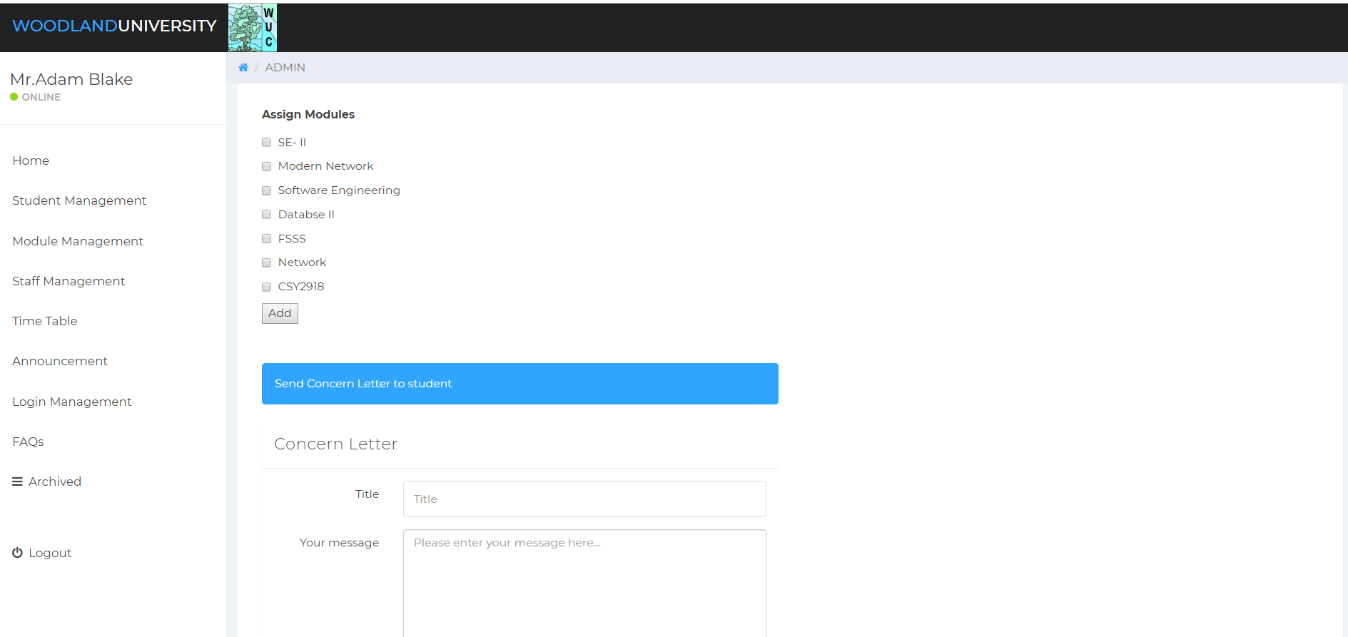

*Fig: Student access*

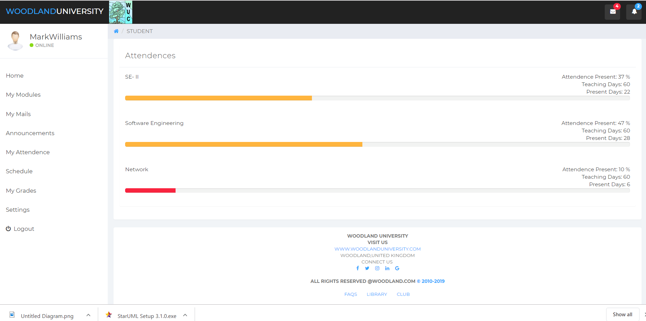

*Fig: student attendee page*

# Test Strategy

## Overview of Test Strategy

Testing process was carried out based on thorough reading of system prototype. All the tests noted down were done with proper reading of links of the prototype. This testing phase was processed in the aim of giving of our findings and our progress in the context of evaluation of prototype. The rationality of the testing process was distributed according to the following rules where:

* **OK-** The test was termed “Ok” when during testing phase our actual output and expected output matched.
* **Partial OK-** The test was termed to be “Partial OK” when some of the expected result matched with actual output.
* **NOT OK-** The test was termed “NOT OK” when our expected output and actual output differed in number of areas.

## Sample Test Results

To every executed test, its documentation contains:

1. Action Performed
2. Expected Output
3. Actual Output
4. Evaluation

|  |  |  |  |  |
| --- | --- | --- | --- | --- |
| S. N | Action | Expected Output | Actual Output | Evaluation |
| **Page Loading** | | | | |
|  | Home Page load | Home page expected to load successfully with no errors | Home Page loaded successfully | OK |
|  | Admin Home load | Admin Home page to load successfully with no errors | Admin Home page loaded successfully | OK |
|  | Staff Home load | Staff Home page to load successfully with no errors | Staff Home page loaded successfully | OK |
| **Responsive Test** | | | | |
|  | Home Page load | Home page load responsively with no content overlay | Home page loaded responsively | OK |
|  | Admin Home load | Admin page load responsively with no content overlay | Admin home loaded responsively | OK |
|  | Staff Home load | Staff page load responsively with no content overlay | Staff information was cluttered and overlaid | Partially OK |
|  | Student Home Load | Student page load responsively with no content overlay | Student information was cluttered and overlaid | Partially OK |
| **Login** | | | | |
|  | Login form left empty | Form validation will not let the login session to be activated. | Form validation requests users not to leave empty form. | OK |
|  | Login form filled with correct credentials | Login to admin, staff or student according to credentials provided | Login with admin, staff or student according to credentials provided | OK |
| **Homepage** | | | | |
|  | Querying on FAQ section | Questions will be allowed to be queried | Questions were sent to administrator portal for administrator to reply | OK |
| **Admin Section** | | | | |
|  | Managing students | Valid inputs will add student credentials onto database of students also will be able edit, delete and archive | Valid inputs resulted in adding student records on the database and to be viewed on student table also editing, archiving and deleting students credentials | OK |
|  | Adding student through spreadsheet file | Student csv file would be used to fill all the forms in the database | Student details were filled directly by use of csv file | OK |
|  | Adding modules | By filling a manual form, the module addition would be completed | Modules were added successfully using form | OK |
|  | Adding staff through form | Staffs would be added by inserting staff credentials | Staffs are added in the database | OK |
|  | Adding timetable | Timetable is added using a form as per the module | Timetable was added accordingly | OK |
|  | Adding announcement | Announcements would be added, deleted as per action of admin | Adding and deletion of announcement was possible | OK |
|  | Managing FAQs | Queries asked at home page would be answered by admin | Admin was able to answer all the queries | OK |
|  | Logging out | Admin would be able logout of the session | Admin was able to logout of session | OK |
| **Staff Section** | | | | |
|  | Managing Modules | Modules would be displayed and adding weekly contents, assignments and discussion would be allowed. | Modules were displayed and weekly contents addition as well as assignments and discussion were allowed. | OK |
|  | Managing Attendance | Attendance csv file would be used to view attendance record of a student | Attendance csv file was used to view attendance record of a student | OK |
|  | Grade Managing | All the student submissions would be visible, and staff would be able to grade accordingly | All the student submissions were visible, and staff was able to grade | OK |
|  | Managing Announcements | Announcements would be added, deleted as per action of staff | Announcements were added, deleted as per action of staff | OK |
|  | Viewing timetable | Staff would be able to view the timetable managed by the admin | Staff was able to view his/her timetable | OK |
|  | Viewing Students | Staff would be able to view students under the module leader | Staff sees students under his/her module | OK |
|  | Settings | Staff would be able to change their password | Staff was successful in changing his/her password | OK |
|  | Logging out | Staff would be able logout of the session | Staff was able to logout of session | OK |
| **Student Section** | | | | |
|  | Accessing Modules | Modules would be displayed, and access weekly contents, assignments and discussion would be allowed. | Modules were displayed and weekly contents access as well as assignments and discussion were allowed. | OK |
|  | Viewing Attendance | Attendance would be displayed by a graphical representation | Attendance was displayed by a graphical representation | OK |
|  | Viewing Mails | Mails from admin and staff would be visible in this segment | Mails was displayed in this section | OK |
|  | Viewing Announcements | Announcements would be displayed | Announcements were displayed, | OK |
|  | Viewing timetable | Student would be able to view the timetable managed by the admin | Student was able to view his/her timetable | OK |
|  | Viewing Grades | Student would be able to view grades examined by module leader | Student was able to view grades examined by module leader | OK |
|  | Settings | Student would be able to change their password | Student was successful in changing his/her password | OK |
|  | Logging out | Student would be able logout of the session | Student was able to logout of session | OK |

### Black Box Testing

Login

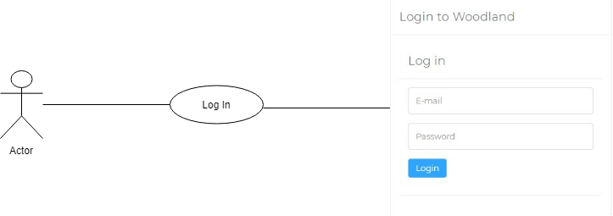

*Fig: Login Blackbox testing*

**Equivalence 1**: If login form left empty, form validation would come to action and request user not to leave empty form. Error message would be displayed

**Equivalence 2:** Incorrect credentials would result in error display and contents of form wouldn’t be uploaded.

**Equivalence 3:** Correct login would direct actor to the designated portal of credentials supplied in the form.

**Add**

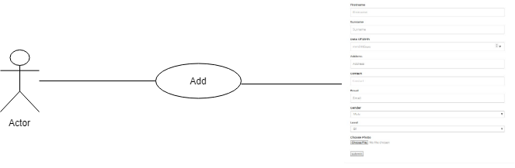

*Fig: Blackbox testing add*

**Equivalence 1**: If addition form left empty, form validation would come to action and request user not to fill the addition form. Error message would be displayed about empty form.

**Equivalence 2:** Incorrect credentials would result in error display and contents of form wouldn’t be uploaded to the system.

**Equivalence 3:** Correct addition of contents would add the values that are submitted to the form.

**FAQ**

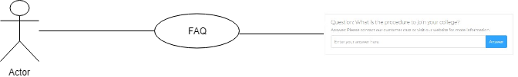

*Fig: Blackbox testing FAQs*

**Equivalence 1**: If the form is left empty, no questions are answered by actor.

**Equivalence 2:** Inserting on the FAQ form would enable actor to answer queries and are displayed on home screen.

# System Evaluation

The process of evaluating the complete performance of the system to erupt how this system is likely to act in the market. The system evaluation brings the complete system in play.

## Usability Evaluation Strategy

Usability evaluation strategy mainly gives the focus on how the users can learn the system easily, efficiently and effectively and use it to gain their goal. It also helps to know the user’s satisfaction on the project. Usability refers to the quality of the user’s experiences when interacting with any system or any devices or software.

The usability is one dimensional property, not single, of a product or user interface. It is the combination of factors including.

* Intuitive design:

When the users see any devices or the system, they recognize exactly what to do next. User’s attention is directed to the process that are important.

* Memorability:

It depends on the user, after visiting the sites how they can remember enough to use in coming days.

* Error frequency and severity:

When using the system by the user the errors may occur or the user often make errors. It is seen how serious the errors are hoe to fix them in less time.

* Subjective satisfaction:

It refers to liking the system by the users.

## System Pilot Trials

|  |  |  |
| --- | --- | --- |
| Attributes | Accepted datatype | Must be |
| Email and password | VARCHAR (255) | The text fields of email and password accepts all the characters. |
| Firstname, surname, contact, email, level qualification | VARCHAR (255) | The attributes included in the student’s and staff’s forms accepts any types of characters. |
| Date of birth, hire date, current date | DATE | The date is stored in the form of format YYYY-MM-DD |
| Gender | CHAR(1) | The gender only accepts a character. E.g. if the user is male then gender text accepts ‘M’ |
| Time | TIME | The time stored in format 00:00:00. |
| Class- time | INT(11) | Accepts only number. No string value is accepted. |
| Details and title in announcement | VARCHAR(255) | Must accept string value. |

## System Trial Results:

|  |  |  |
| --- | --- | --- |
| Attributes | Accepted value | Actual results |
| Email and password | Correct string value is inserted. | Login successful. |
| If inserted incorrect invalid input | Login unsuccessful. |
| Firstname, surname, contact, email, level qualification | Inserted any type of data for the attributes. | The attributes included in the student’s and staff’s forms accepts any types of characters. |
| Date of birth hire date | Date is being selected through select option | The date is successfully stored in the form of format YYYY-MM-DD with no errors. |
| Gender | The gender has been selected. | The gender only accepts a character. E.g. if the user is male then gender text accepts ‘M’. User can only select one type at a time |
| Time | Selection is done for time | The time successfully stored in format 00:00:00. |
| Null value sent | By default, the time is saved in format 00:00:00. |
| Class- time | Number is sent | The data is accepted by system. |
| String value inserted | By default, the value is stored as 0. |
| FQS | Inserted all types of characters. | Accept values successfully. |
| Change password | Inserted all types of data | Accepts successfully. |

# Project Conclusions

The main target of this project is to create software which can manage the university system systematically. The system is divided in three different portal that is admin, staff and students, whereas the admin can control over all the system, where he/she can add, delete, archive, and many more actions in student, modules also he/she can set the timetable of modules, can add announcement in the tables. In admin area all the data of students, modules, announcements, timetable are displayed in the body.

In staff area, all the data of modules in which staff is assigned will be display also attendance management table of student’s modules can see and update by using excel file. Not only that the module leader can see all the records of their students in the system. Also, modules leader can archive there announcements according to the need of system. The module leader can see their schedule or routine in through the system. In grade management the module leader can see the assignment submitted by students also can download and can grade the assignments after validation. Not only that the module leader can add assignments, contents of modules and also, he/she can also enable or disable the needed assignments. The module leader can change their password as per their required or in future use to keep the

In student home, student can see their modules in which they were assigned also they can see details about their modules, modules activity, the assessments posted by the module leaders also they can submit their assignments where the link of the assignments is once enable by tutor. Not only they can download the assignment brief provided by tutor. In module discussion the students can discuss about the module with their friends.

Whereas, waterfall methodology is used to in the system to find out problems in the systems also to fulfil the requirements needed by the university. Where is in interview plans and findings all the question which were asked by clients to get clear about the work to perform. Also, some of other related software systems were tested so to get the clear and more highly feature in the system with their pros and cons. The group have meeting to discuss about the problem domain and the solution which can withdraw the issues and problems from the system.

The system is tested from different criteria, checked for the security which must need to maintain in the system for security propose. The testing is done by the using white-box and black box methods which helps to identify the problem quickly and check in both in user base and database criteria. The system is designed in such a way that it can be more user friendly, stable, reliable and to complete all the functionality that required in need. Most of target are achieved in the project where as some of them are still there which where are not done in the system.

If again our group is offered to work in same project, first obviously will remove all the issues from the system. Like will be creating dairy system, there will be monitor having separate role also can start different thread for different module. Not only that the session can be ended if the site left unseen or left open application for more than five minutes. And many mores ideas can be implemented in the application which can make it more stable, user friendly and reliable.

# Project Management

## Project Gantt Chart/WBDS/Activity List

Activity List:

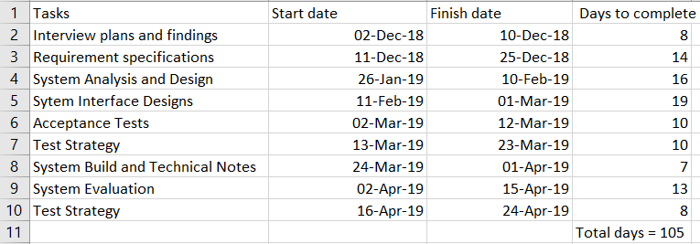

*Fig: activity list for making Gantt char*

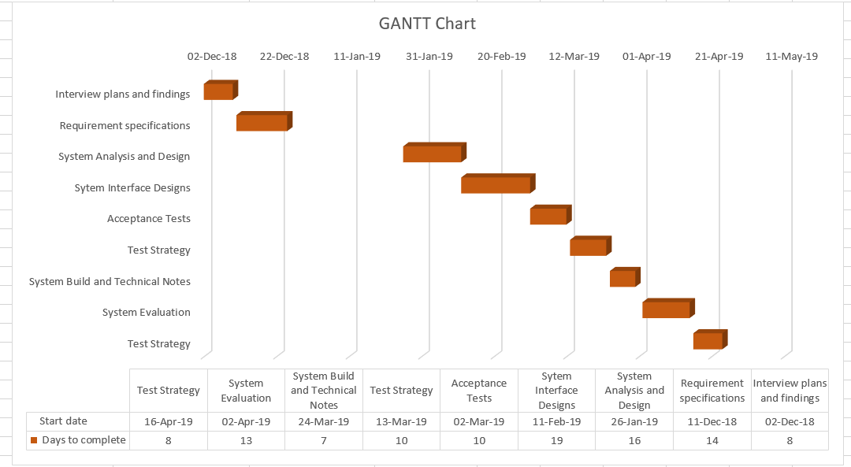

*Fig: showing Gantt chart of the activity list*

## Project Meeting Minutes

|  |  |  |  |
| --- | --- | --- | --- |
| Number of meeting | Time period | Number of people | Discussions |
| Meeting 1 | 1 and half hour | 1)Ramesh kunwar  2)Shivani Porwal(leader)  3)Anup thapa  4)Suman chaulagain  5)Subesh thapa  6)Chirayu subedi  7)Siddhant ghimire  8) Madhu Rana  9) Ritesh jha | Designing of the home page |
| Meeting 2 | 2 hours | Every one of the groups memeber | Add, delete edit achieve in admin |
| Meeting 3 | 2 hour and half | Everyone except chirayu | Displaying of add delete edit |
| Meeting 4 | 3 hours | Each member except siddhnat ghimire | Separate username and password for staff and adding editing deleting module staff |
| Meeting 5 | Half hour | Every member of the group | Spate user name and password and viewing courses, module, attendance etc. |
| Meeting 6 | 4 Hour | Everyone was present in meeting |  |

*Table: Meeting plan and minutes*

## Project Quality Plan/ Strategy

In meeting we discussed about the different plan and each member of the group should follow every plan and work according to it and be always available for the meeting and discussion. We had gathered for meeting many times and discussed how we can make a good website and every member of the team should work equally and properly. We planned on how to design the software which should look simple and attractive. There should be good design and we planned not to include too colorful design which would not be an eye-catching color. We also planned to make like Nile website and we have designed and worked on it similar to that. Our plan was it should be very user friendly and reliable to use. On that vison we had been working and we planned to meet every two days in a week and work for this project. We planned to create separate account for admin staff and students. At first, we designed the home page and only we had gone further in it. We also planned to make responsive design and we had followed according to it. We had design in simple way that admin can change edit add delete module and many more whereas staff can add delete assignment, lecture notes etc., and student can view module announcement calendar and many more which is design in a proper way. So, planning is very important for the project like this and we should act according to it.

## Project Work Log

**Work Log**

|  |
| --- |
| **Task** |
| **Introduction** | Shivani Purwar | Anup Thapa | Suman Chalagain | Ritesh Jha | Chirayu Subedi | Ramesh Kunwar | Subesh Thapa | Madhu Rana | Siddhant Ghimire |
| Project Background | 100% | - | - | - | - | - | - | - | - |
| Project Aims and Objectives | 30% | 10% | 20% | 10% | - | 10% | 10% | 10% | - |
| Project Development Methodology | 20% | - | 80% | - | - | - | - | - | - |
| **Requirements Engineering** | Shivani Purwar | Anup Thapa | Suman Chalagain | Ritesh Jha | Chirayu Subedi | Ramesh Kunwar | Subesh Thapa | Madhu Rana | Siddhant Ghimire |
| Design Interview Questions | 20% | 15% | 15% | 10% | - | 10% | 10% | 20% | - |
| Interviews | 12% | 11% | 11% | 11% | 11% | 11% | 11% | 11% | 11% |
| Write Up Interview Answer |  | 20% |  |  | 80% |  |  |  |  |
| Comparable Software System Review | - | - | - | 100% | - | - | - | - | - |
| Development Relevant Legislation |  |  |  | 100% |  |  |  |  |  |
| **Requirements Specification** | Shivani Purwar | Anup Thapa | Suman Chalagain | Ritesh Jha | Chirayu Subedi | Ramesh Kunwar | Subesh Thapa | Madhu Rana | Siddhant Ghimire |
| Problem Domain Identification | 25% | 25% | 50% | - | - | - | - | - | - |
| Functional Requirements |  |  |  |  |  | 100% |  |  |  |
| Performance Requirements |  | 100% |  |  |  |  |  |  |  |
| Design Constraints | - | - | - | - | - | - | 100% | - | - |
| Commercial Constraints | - | 100% | - | - | - | - |  | - | - |
| **System Analysis and Design** | Shivani Purwar | Anup Thapa | Suman Chalagain | Ritesh Jha | Chirayu Subedi | Ramesh Kunwar | Subesh Thapa | Madhu Rana | Siddhant Ghimire |
| Textual Analysis | 100% | - | - | - | - | - | - | - | - |
| Significant Event Analysis | 100% | - | - | - | - | - | - | - | - |
| Commands Queries and Constraints |  |  |  |  |  |  |  |  |  |
| First Draft BON System Architecture Diagram | - | 100% | - | - | - | - | - | - | - |
| BON Class& cluster Charts | - | 100% | - | - | - | - | - | - | - |
| **System Interface Designs** | Shivani Purwar | Anup Thapa | Suman Chalagain | Ritesh Jha | Chirayu Subedi | Ramesh Kunwar | Subesh Thapa | Madhu Rana | Siddhant Ghimire |
| Wireframes | - | - | - | - | - | - | - | 100% | - |
| System Navigation Diagram |  | - |  | 100% | - | - | - | - | - |
| System Screen Mock-Ups | - | - |  | - |  | 100% | - | - | - |
| System Activity Event Diagrams |  |  |  | 100% |  |  |  |  |  |
| System Database Design | 25% | - | - | 25% | - | 50% | - | - | - |
| System Build and Technical Notes | - | - | - | - | - | 100% | - | - | - |
| Test Strategy | - | - | 100% | - | - | - | - | - | - |
| Project Management | - | 35% | - | 65% | - | - | - | - | - |
| System Evaluation | - | 100% | - | - | - | - | - | - | - |
| Conclusion | 50% | 10 | 10% | - | 10% | 10% | - | 10% | - |
| Design Document Typewriting and Formatting | 25% | 50% | - | - | - | 25% | - | - | - |
| Questionnaire | - | - | - | - | - | - | - | 100% | - |
| Presentation | 11% | 11% | 11% | 11% | 11% | 11% | 12% | 11% | 11% |
| Presentation Delivery | 10% | 10% | 15% | 10% | 10% | 15% | 10% | 10% | 10% |

# 

# References

* Draw.io. (2019). Flowchart Maker & Online Diagram Software. [online] Available at: https://www.draw.io [Accessed 23 Jan. 2019].
* Techopedia.com. (2019). What is a Functional Requirement? - Definition from Techopedia. [online] Available at: https://www.techopedia.com/definition/19508/functional-requirement [Accessed 23 Jan. 2019].
* <https://www.usability.gov/what-and-why/usability-evaluation.html>

# 

# Appendix

## Presentation Slides



